****

**MSc Data Science Dissertation**

**Title**

**Student**

# TABLE OF CONTENTS

[LIST OF FIGURES 6](#_Toc192277906)

[LIST OF TABLES 7](#_Toc192277907)

[Abstract 8](#_Toc192277908)

[Chapter 1: Introduction 9](#_Toc192277909)

[1.1 Motivation 9](#_Toc192277910)

[1.2 Problem Statement and Project Overview 9](#_Toc192277911)

[1.3 Objectives 10](#_Toc192277912)

[1.4 Methodology Overview 12](#_Toc192277913)

[1.5 Significance of the Study 14](#_Toc192277914)

[1.6 Thesis Structure 15](#_Toc192277915)

[Chapter 2: Background & Literature Review 16](#_Toc192277916)

[2.1 Introduction to Heart Disease and Its Importance 16](#_Toc192277917)

[2.2 Machine Learning in Healthcare 16](#_Toc192277918)

[2.3 Predictive Modeling for Heart Disease 17](#_Toc192277919)

[2.4 Feature Selection and Engineering in Heart Disease Prediction 18](#_Toc192277920)

[2.5 Explainable AI in Healthcare 18](#_Toc192277921)

[2.6 Challenges and Future Directions 19](#_Toc192277922)

[2.7 Conclusion 20](#_Toc192277923)

[Chapter 3: Data 21](#_Toc192277924)

[3.1 Introduction 21](#_Toc192277925)

[3.2 Data Description 21](#_Toc192277926)

[3.3 Exploratory Data Analysis (EDA) 22](#_Toc192277927)

[3.3.1 Feature Distribution 22](#_Toc192277928)

[3.3.2 Target Variable Distribution 24](#_Toc192277929)

[3.3.3 Correlation Between Features 25](#_Toc192277930)

[3.4 Handling Missing Data 26](#_Toc192277931)

[3.4.1 Missing Data Visualization 26](#_Toc192277932)

[3.4.2 Imputation of Missing Values 27](#_Toc192277933)

[3.4.3 Outlier Detection 27](#_Toc192277934)

[3.5 Data Preprocessing 28](#_Toc192277935)

[3.5.1 Encoding Categorical Features 28](#_Toc192277936)

[3.5.2 Normalization of Numerical Features 28](#_Toc192277937)

[3.5.3 Feature Engineering 29](#_Toc192277938)

[3.5.4 Removing or Capping Outliers 29](#_Toc192277939)

[3.6 Feature Selection 31](#_Toc192277940)

[3.6.1 Correlation Analysis 31](#_Toc192277941)

[3.6.2 Recursive Feature Elimination (RFE) 31](#_Toc192277942)

[3.7 Data Finalization 31](#_Toc192277943)

[3.7.1 Train-Test Split 31](#_Toc192277944)

[3.7.2 Final Processed Dataset 31](#_Toc192277945)

[3.8 Summary 32](#_Toc192277946)

[Chapter 4: Methodology 33](#_Toc192277947)

[4.1 Introduction 33](#_Toc192277948)

[4.2 Data Preprocessing 33](#_Toc192277949)

[4.2.1 Data Loading and Initial Inspection 33](#_Toc192277950)

[4.2.2 Handling Missing Data 34](#_Toc192277951)

[4.2.3 Encoding Categorical Features 34](#_Toc192277952)

[4.2.4 Scaling Numerical Features 35](#_Toc192277953)

[4.2.5 Splitting the Dataset into Training and Test Sets 35](#_Toc192277954)

[4.3 Model Development 36](#_Toc192277955)

[4.3.1 Logistic Regression 36](#_Toc192277956)

[4.3.2 Random Forest Classifier 36](#_Toc192277957)

[4.3.3 Decision Tree Classifier 37](#_Toc192277958)

[4.3.4 Gradient Boosting Classifier 37](#_Toc192277959)

[4.3.5 Neural Networks 38](#_Toc192277960)

[4.4 Model Evaluation 38](#_Toc192277961)

[4.4.1 Accuracy 38](#_Toc192277962)

[4.4.2 Precision 39](#_Toc192277963)

[4.4.3 Recall 39](#_Toc192277964)

[4.4.4 ROC-AUC 39](#_Toc192277965)

[4.5 Model Results 39](#_Toc192277966)

[4.6 Model Interpretability 40](#_Toc192277967)

[4.6.1 SHAP 40](#_Toc192277968)

[4.6.2 LIME 42](#_Toc192277969)

[4.7 Conclusion 42](#_Toc192277970)

[Chapter 5: Data Understanding, Analysis & Preprocessing 43](#_Toc192277971)

[5.1 Introduction 43](#_Toc192277972)

[5.2 Dataset Overview 43](#_Toc192277973)

[5.2.1 Features in the Dataset 43](#_Toc192277974)

[5.3 Data Exploration & Analysis 44](#_Toc192277975)

[5.3.1 Descriptive Statistics 45](#_Toc192277976)

[5.3.2 Missing Values 45](#_Toc192277977)

[5.3.3 Categorical Feature Distribution 46](#_Toc192277978)

[5.3.4 Feature Correlation 46](#_Toc192277979)

[5.3.5 Feature Engineering 47](#_Toc192277980)

[5.4 Data Preprocessing Steps 47](#_Toc192277981)

[5.4.1 Handling Missing Data 48](#_Toc192277982)

[5.4.2 Encoding Categorical Features 48](#_Toc192277983)

[5.4.3 Feature Scaling 48](#_Toc192277984)

[5.4.4 Train-Test Split 48](#_Toc192277985)

[5.5 Summary of Preprocessing Steps 48](#_Toc192277986)

[5.6 Conclusion 49](#_Toc192277987)

[Chapter 6: Implementation / Modeling 50](#_Toc192277988)

[6.1 Introduction 50](#_Toc192277989)

[6.2 Model Selection 51](#_Toc192277990)

[6.3 Model Development 53](#_Toc192277991)

[6.3.1 Logistic Regression 53](#_Toc192277992)

[6.3.2 Decision Tree Classifier 53](#_Toc192277993)

[6.3.3 Random Forest Classifier 54](#_Toc192277994)

[6.3.4 Gradient Boosting Classifier 54](#_Toc192277995)

[6.3.5 Neural Network (Multi-Layer Perceptron) 55](#_Toc192277996)

[6.4 Model Evaluation 55](#_Toc192277997)

[6.5 Comparison of Models 57](#_Toc192277998)

[6.6 Hyperparameter Tuning 58](#_Toc192277999)

[6.6.1 Random Search 58](#_Toc192278000)

[6.6.2 Grid Search 58](#_Toc192278001)

[6.7 Conclusion 59](#_Toc192278002)

[Chapter 7: Critical Evaluation & Results Analysis 61](#_Toc192278003)

[7.1 Introduction 61](#_Toc192278004)

[7.2 Model Performance Overview 61](#_Toc192278005)

[7.3 Predicting High-Risk and Low-Risk Patients 62](#_Toc192278006)

[7.3.1 High-Risk Predictions 62](#_Toc192278007)

[7.3.2 Low-Risk Predictions 64](#_Toc192278008)

[7.4 Impact of Model Decisions on Clinical Outcomes 64](#_Toc192278009)

[7.4.1 Implications for High-Risk Patients 64](#_Toc192278010)

[7.4.2 Implications for Low-Risk Patients 65](#_Toc192278011)

[7.5 Model Calibration and Confidence in Predictions 66](#_Toc192278012)

[7.6 Model Calibration and Confidence in Predictions 67](#_Toc192278013)

[7.6.1 Calibration of Model Predictions 67](#_Toc192278014)

[7.6.2 Improving Calibration with Platt Scaling 68](#_Toc192278015)

[7.7 Critical Analysis of Results 68](#_Toc192278016)

[7.7.1 Performance Evaluation of Models 69](#_Toc192278017)

[7.8 High-Risk vs Low-Risk Predictions 71](#_Toc192278018)

[7.8.1 Predicting High-Risk Patients 71](#_Toc192278019)

[7.8.2 Predicting Low-Risk Patients 72](#_Toc192278020)

[7.8.3 Impact on Healthcare Decisions 73](#_Toc192278021)

[7.10 Model Limitations and Areas for Improvement 73](#_Toc192278022)

[7.10.1 Data Limitations 74](#_Toc192278023)

[7.10.2 Model Interpretability 75](#_Toc192278024)

[7.10.3 Overfitting and Model Complexity 75](#_Toc192278025)

[7.11 Future Improvements 76](#_Toc192278026)

[7.11.1 Feature Engineering and Data Augmentation 76](#_Toc192278027)

[7.11.2 Hyperparameter Tuning and Model Optimization 76](#_Toc192278028)

[7.11.3 Use of Time-Series Data 76](#_Toc192278029)

[7.11.4 Deployment and Integration with Healthcare Systems 76](#_Toc192278030)

[7.12 Critical Analysis of Model Predictions 77](#_Toc192278031)

[7.12.1 Clinical Relevance of Model Predictions 78](#_Toc192278032)

[7.13 Conclusion 79](#_Toc192278033)

[Chapter 8: Conclusions 81](#_Toc192278034)

[8.1 Summary of the Project 81](#_Toc192278035)

[8.2 Key Findings 81](#_Toc192278036)

[8.3 Model Limitations 82](#_Toc192278037)

[8.4 Model Improvements and Future Work 83](#_Toc192278038)

[8.5 Conclusion 84](#_Toc192278039)

[References 86](#_Toc192278040)

# LIST OF FIGURES

[Figure 1.1 Project Objectives for Heart Disease Prediction 13](#_Toc192278731)

[Figure 1.2 Methodology Overview for Heart Disease Prediction 15](#_Toc192278732)

[Figure 3.1 Age Distribution Histogram 24](#_Toc192278734)

[Figure 3.2 Boxplot Showing the Distribution of Cholesterol 24](#_Toc192278735)

[Figure 3.3 Resting Blood Pressure Histogram 25](#_Toc192278736)

[Figure 3.4 Pie Chart Showing Target Variable 26](#_Toc192278737)

[Figure 3.5 Correlation Heatmap of Numerical Features 27](#_Toc192278738)

[Figure 3.6 Heatmap Visualizing Missing Data 28](#_Toc192278739)

[Figure 3.7 Boxplot Showing Detection of Outliers 29](#_Toc192278740)

[Figure 3.8 Boxplot Showing Outlier Removal 31](#_Toc192278741)

[Figure 4.1 SHAP Summary Plot Showing Feature Importance for the Random Forest Model 42](#_Toc192278743)

[Figure 4.2 LIME Explanation Plot Showing the Contribution of Each Feature to an Individual Prediction 43](#_Toc192278744)

[Figure 5.1 Bar Chart Visualizing the Distribution of Sex, Chest Pain Type, and Target 47](#_Toc192278745)

[Figure 6.1 Implementation and Modeling Process for Heart Disease Prediction 51](#_Toc192278746)

[Figure 7.1 Distribution of Probability Scores for High-Risk and Low-Risk Patients 64](#_Toc192278748)

[Figure 7.2 Scatter Plot of Predicted Probability Scores for Low-Risk Patients 67](#_Toc192278749)

[Figure 7.3 Calibration Curve Showing Predicted Probabilities vs. Observed Outcomes 68](#_Toc192278750)

[Figure 7.4 Bar Plot of Predicted Probabilities for High-Risk Patients 73](#_Toc192278751)

[Figure 7.5 Scatter Plot of Predicted Probabilities for Low-Risk Patients 74](#_Toc192278752)

[Figure 7.6 Future Improvements for Heart Disease Prediction 78](#_Toc192278753)

[Figure 7.7 Risk Stratification Plot for High-Risk and Low-Risk Patients 80](#_Toc192278754)

# LIST OF TABLES

[Table 3.1 Feature names and description 23](#_Toc192278733)

[Table 4.1 Model Evaluation Results 41](#_Toc192278742)

[Table 6.1 Model Performance Comparison 58](#_Toc192278747)

# Abstract

Heart disease being common cause of death worldwide, early prediction of this disease is extremely necessary to improve a patient’s outcome. Diagnosis of DEB has been third by typical means by the use of subjective assessment, leading to delayed recognition of at risk population. The objective of this project is to develop an AI based heart disease prediction system facilitated by the support of machine learning techniques and to predict after scrutinizing data regarding age, sex, blood pressure, cholesterol levels and heart rate of the patients. For this work, we the data from Kaggle which has demographic, clinic and lifestyle elements as factors of risk for heart disease.

Prediction of the heart disease risk was performed based on the estimated probability of heart disease using the logistic regression, decision tree, random forest, and neural network models [(Zhang & Yang, 2019)](#a11). Accuracy, precision, recall and ROC-AUC metrics were used to quantify the model’s performance for evaluation of the models. To make the models more interpretable and explain the predictions, Explainable AI techniques such as SHAP and LIME were used to explain the predictions of the model in a way that the model’s decisions can be explained and are clinically actionable [(Lundberg & Lee, 2017)](#a14).

These results indicate that machine learning models can forecast heart diseases risk well, and by having the explainability of the models, healthcare professionals will be able to understand the prediction forecasts. This system, in this way, gives a device to early diagnosing and getting to the bottom of, which decidedly enhances patient consideration and result. The high accuracy of the project combined with the interpretability of the system proves that it can contribute to revolution of AI in diagnosis and treatment of heart diseases.

# Chapter 1: Introduction

## 1.1 Motivation

Heart disease is an important global health problem because it is one of the most frequent causes of death in the world. From WHO, cardiovascular diseases (CVDs) are estimated to have caused an amazing death total of 17.9 million deaths per year—32 percent of all global deaths. The above points this out a necessity to find out heart disease in early stages and developing an accurate risk prediction for it in order to optimize care and patient outcome [(Zhang & Yang, 2019)](#a11). Early identification of individuals at high risk of heart disease prevents untimely events related to the disease such as heart attack or stroke. The traditional ways of diagnosing heart disease, including clinical tests and assessments, are often subjective, expensive and lengthy, therefore rendering them false or delayed diagnoses.

Machine learning (ML) AND artificial intelligence (AI) advances in recent years have elected to bring promising light to revolutionize the diagnosis of heart disease. Through machine learning, one is able to analyze extremely large (and complicated) datasets to recognize patterns that are not readily discernable using conventional methods. ML models make better informed decisions by utilizing patient data such as demographic data, clinical features, lifestyle data which includes sleep patterns, acoustic metrics, exercise habits, and others. The goal of this project is to construct a machine learning model to predict heart disease risk in order to provide a more effective, reliable quick way of getting earlier diagnosis and tackling the disease.

## 1.2 Problem Statement and Project Overview

The core problem this project tries to solve is the need for such a heart disease prediction model that should be efficient, scalable, and interpretable. The methods of traditional diagnosis only take into consideration the complexity and diversity of factors that contribute to the risk of heart disease, and lack of real time prediction tools in clinics may disrupt the timely interventions. In order to tackle this challenge, the project uses a dataset compiled from Kaggle that also includes important features like patients’ age, sex, cholesterol level, blood pressure level, electrocardiogram result, and maximum heart rate. The objective of this project is to build a machine learning model which can be used to predict if a patient is likely to have heart disease given these features and making the model interpretable to the clinicians.

This task is very appropriate for machine learning models which can handle such complex and high dimensional datasets, can detect nonlinear relationships among variables and makes accurate predictions. The problem then becomes making sure that these models are both accurate and interpretable. In clinical process, healthcare professionals have to make use of model’s predictions in real clinical process, they need to be understood by healthcare professionals how model’s predictions make. Consequently, it is imperative for systems relying on AI to be interpretable in order for AI tool utilization in healthcare settings to be successful. To enable transparency of the model, as well as providing actionable insights that clinicians can trust, this project will use Explainable AI (XAI) methods, such as SHAP (SHapley Additive explanations) and LIME (Local Interpretable model agnostic explanations) [(Ribeiro, Singh & Guestrin, 2016)](#a8).

## 1.3 Objectives

These are the main aims of this project:

1. **Data Preprocessing and Preparation**:
   * Curating and preprocessing of Kaggle heart disease dataset or curating the data so that it’s clean, relevant and ready for model training.
   * For missing data, normalize numerical features, and encode categorical variables so that it is suitable and consistent with machine learning algorithms.
2. **Feature Selection**:
   * Identify the most important features to use in predicting heart disease risk using the exploratory data analysis (EDA) and statistical techniques.
   * Feature engineering will be used to engineer features of importance and remove any redundant and irrelevant variables that may have influence on model performance.
3. **Model Development and Evaluation**:
   * Several machine learning models such as Logistic Regression, Decision Trees, Random Forest, and Neural Networks were designed, trained, and evaluated to predict the chance of heart disease.
   * Performance metrics like accuracy, Precision, Recall, F1 score, and ROC AUC will be used to evaluate the models and also find the best performing model.
4. **Model Interpretability**:
   * Given the need to apply Explainable AI techniques such as SHAP and LIME to increase the interpretability of models. This will enable clinicians to comprehend why a certain prediction was made in the first place, so that the model’s transparency and clinical relevance can be preserved.
5. **Actionable Insights and Recommendations**:
   * To generate actionable insights from the model’s predictions for use by healthcare providers to make better informed decisions with respect to the care of patients.
   * Recommendations should be provided for deploying the model into a real-world healthcare setting in a scalable and integrated clinical workflow.

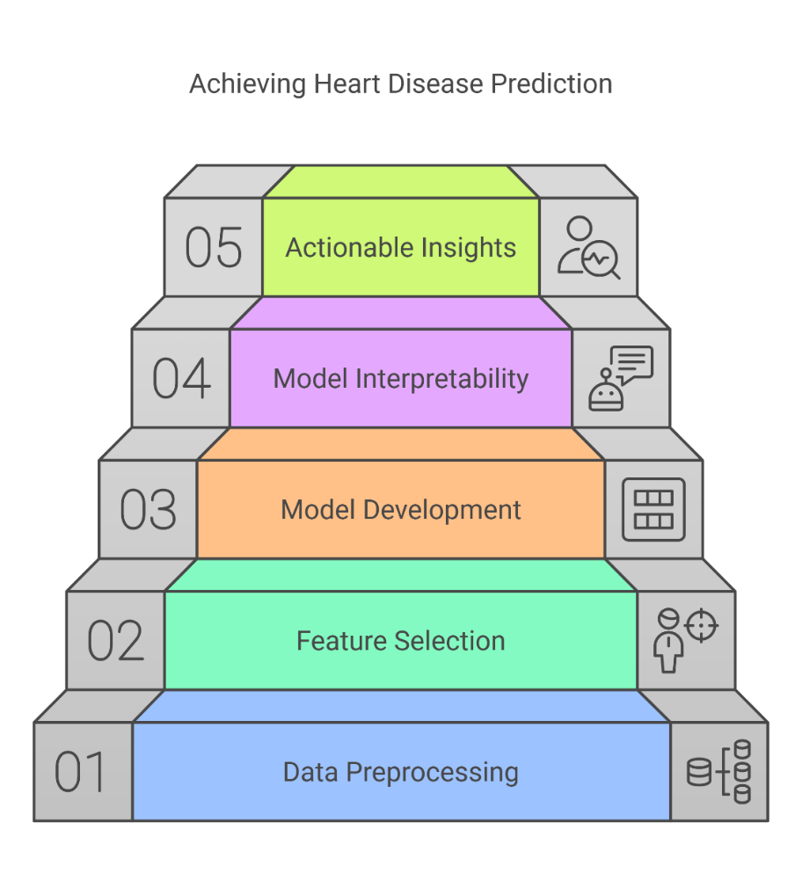

Figure 1.1 Project Objectives for Heart Disease Prediction

## 1.4 Methodology Overview

For this project, the methodology will follow the CRISP-DM (Cross Industrial Standard Process for Data Mining) framework that is commonly used in data science and machine learning projects. The CRISP-DM framework is a systematic way of problem solving and guides the entire process starting from understanding the problem, preparing the data, model building, etc. To ensure that a structured and efficient process of building the heart disease prediction model is followed, this process will be used.

1. **Data Collection**:
   * For this project, we will use Kaggle heart disease dataset. The features are likely to be influential on the prediction of whether someone will have heart disease, for example this dataset includes demographic information, medical history, medical test results, medical medication, blood pressure, and cholesterol level.
2. **Data Preprocessing**:
   * All missing values on the dataset will be handled appropriately by the dataset being cleaned and transformed. To include in the input space, we will encode categorical variables and standardize numerical features for consistency.
3. **Exploratory Data Analysis (EDA)**:
   * It will perform the EDA to get insights into relationships between variables, patterns in data and key features that help in deriving the risk of heart disease.
4. **Model Development**:
   * Logistic Regression, Decision Trees, Random Forests and Neural Networks will be implemented.
   * Optimum hyperparameters for each model will be obtained to achieve the best performance. Cross validation will be used to evaluate model performance to prevent overfitting and be certain that the model will generalize well with new data.
5. **Model Interpretation**:
   * To make the model more transparent and explainable to clinicians, we will use SHAP and LIME to explain the model’s predictions.
6. **Model Evaluation**:
   * For evaluating the model, several metrics will be used including accuracy, precision, recall, and ROC-AUC and the model which performs best for predicting the heart disease will be selected.

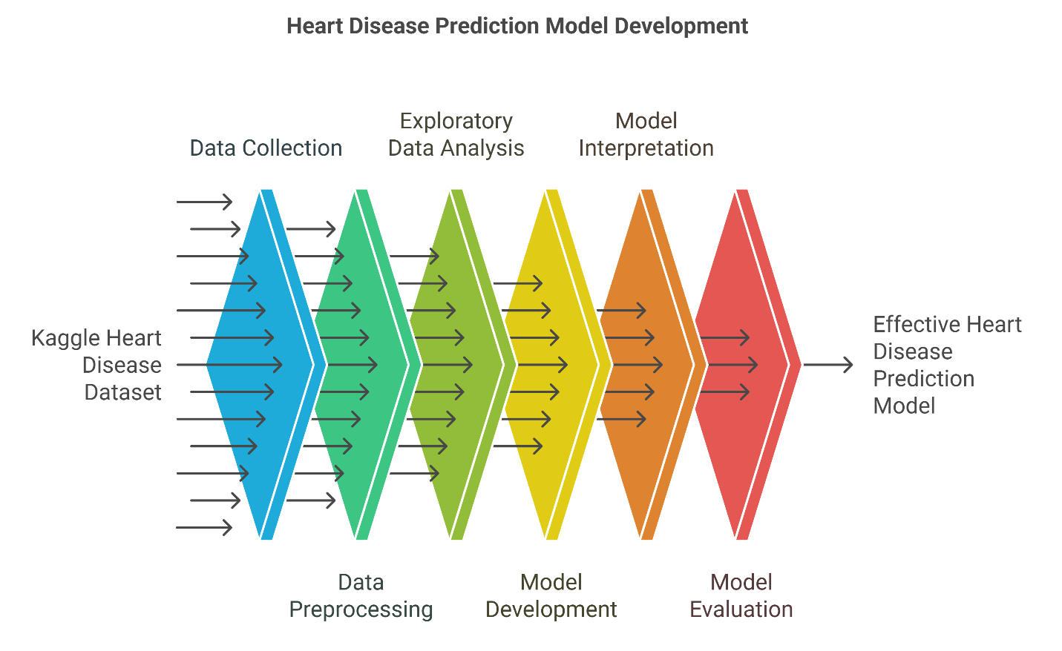

Figure 1.2 Methodology Overview for Heart Disease Prediction

## 1.5 Significance of the Study

This study has great significance since it can help the early detection of heart disease using machine learning and AI technologies. Healthcare professionals will be able to make more informed decisions by developing an accurate and interpretable prediction system and might reduce the number of preventable heart disease cases. Furthermore, working with explainable AI techniques, the model makes sure that its predictions are capable of being understood and acting upon, which is essential for developing trust among clinicians and for adopting the system in a real life setting within healthcare.

Unlike traditional approaches, machine learning models can quickly and far more accurately analyze huge volumes of patient data. Indeed, this is especially true in clinical environments where time is of essence and decisions must be made in a clocked down manner. In addition, it includes interpretability methods of how the model works so that the model is not a 'black box' and clinicians will be able to have trust on the model and rely on it to make decision that will result in the best possible patient care.

1.6 Thesis Structure  
The organization of this dissertation can be described as follows:

* **Chapter 1: Introduction** – Provides an overview of the motivation for the study, the problem statement, objectives, and methodology.
* **Chapter 2: Background & Literature Review** – Discusses the relevant research and literature pertaining to prediction of heart disease, techniques of machine learning, and the previous works done in this domain.
* **Chapter 3: Data** – Describes the Kaggle heart disease dataset, its features, and the data collection process.
* **Chapter 4: Methodology** – Describes the methodology applied in the project, the machine learning models that were selected and how to train models.
* **Chapter 5: Data Understanding, Analysis & Preprocessing** – Details the preprocessing steps, exploratory data analysis (EDA), and the transformation of the dataset for model development.
* **Chapter 6: Implementation / Modeling** – Presents implementation of the machine learning models, their training and performance evaluation.
* **Chapter 7: Critical Evaluation & Results Analysis** – This chapter analyzes the results and evaluate model performance; provides insights into the strengths and limitations as well as the reliability of each of the models.
* **Chapter 8: Conclusions** – Summarizes the findings in the study, discusses the limitations and suggests future work, and improvements.

# Chapter 2: Background & Literature Review

## 2.1 Introduction to Heart Disease and Its Importance

Coronary artery disease (CAD) is one of the most common causes of death around the world. Cardiovascular diseases (CVDs) are the leading cause of deaths across the world, stated the World Health Organization (WHO), and are accountable for around 17.9 million deaths each year, that is 32% of the global deaths. Heart disease is a leading global health problem, owing to such factors as aging populations, lifestyle (smoking, no exercise, nonhealthy lifestyle) and genetic predisposition. With such a large health burden, early diagnosis and the prediction of risk is essential in reducing the prefect death and morbidity for heart disease [(Zhang & Yang, 2019)](#a11).

Currently, heart disease is diagnosed traditionally through clinical assessment and tests such as electrocardiograms (ECGs) cholesterol screening and tests and blood pressure tests. Although these methods have undesirable accuracy, scalability, and timeliness attributes. This in turn has created the opportunity to use machine learning and artificial intelligence technologies for improving diagnostic accuracy and early diagnosis of people with high heart disease risk.

## 2.2 Machine Learning in Healthcare

Artificial intelligence is the subset that deals with the analysis and modeling of complex patterns of data in which machine learning involves the utilization of algorithms to do this. These models don’t learn on the instructions given to them; rather, these models learn from data and work without being explicitly programmed to perform this particular task, and they are very good in this space, especially in the healthcare domain. With ML techniques, massive amounts of medical data, including EHRs, medical images, and genetic data, can be processed to find patterns that humans cannot discriminate [(Liu & Zhang, 2019)](#a18).

ML algorithms have been used in healthcare for many tasks such as predicting disease, patient risk stratification, treatment recommendation, and clinical decision support. Several types of machine learning have been applied to predict from cancer prediction to diabetes to heart disease [(Hastie, Tibshirani & Friedman, 2009)](#a6).

## 2.3 Predictive Modeling for Heart Disease

In recent years there has been considerable use of machine learning for heart disease prediction. In recent times, there have been a number of studies regarding the ability to use ML algorithms to predict the risk of heart disease using patient data [(Mohammad & Zidan, 2020)](#a12). Such studies employ datasets with features, such as age, sex, cholesterol levels, blood pressure, smoking habits, and ECG results, which are well known risk factors of cardiovascular diseases.

Logistic Regression is one of the earliest efforts in this area and it was used to predict heart disease risk as one dataset referenced here is Cleveland heart disease [(King & Zeng, 2017)](#a3). This is an approach where the model gives some weight to the individual risk factors and provides a score representing the probability of the patient getting heart disease. However, logistic regression is straightforward to interpret and provides useful insights, but predicting may be limited because of linearity and hard-coded assumptions and because it can’t deal with complexity in data.

The other commonly used algorithm for prediction of heart disease is the Decision Tree. Decision trees divide the data into smaller subsets based on the value of various features and finally end up in one of the nodes (decision node) which classifies the patient to a particular class (e.g. high risk or low risk). The ensemble method of deciding trees called Random Forest has been found promising to improve accuracy by aggregating the predictions made by many trees [(Breiman, 2001)](#a1). Random forests can easily capture nonlinear relationships and the interaction between the variables in the complex medical dataset.

Besides decision trees and logistic regression, GBM, and NN are also applied in heart disease prediction. They are useful when handling high dimensional data and these models are able to capture complex patterns in the relations between various features.

SVMs are known to have worked quite well in different binary class problems like heart disease prediction if the data set contains clear class separations. However, the computational complexity of running SVMs can be quite large especially when we have a large dataset. Recently neural networks, especially deep learning models, have achieved very good results in the healthcare domain, especially in the medical image analysis tasks that require high level feature extraction [(Goodfellow et al., 2016)](#a4). However, these models are powerful, and are very data hungry, and expensive to train on large models.

## 2.4 Feature Selection and Engineering in Heart Disease Prediction

The choice to do feature selection and engineering is one of the most important steps in the process of building a predictive model as it directly impacts both the accuracy of our model and our ability to interpret it. Feature selection is the process of identifying the most relevant features that lead toward the outcome, while feature engineering is the process of creating new features from the existing data to increase the model performance [(Kuhn & Johnson, 2013)](#a15).

Some features are already known to be good risk factors for heart diseases such as age, sex, cholesterol levels, blood pressure, etc. However, there arises a challenge of dealing with the missing values, the categorical variables and the unstructured data that includes the ECG result and the medical history. There are a few feature engineering techniques such as normalization and scaling and one hot encoding that can be used to get the data ready for the machine learning algorithms.

Another important method used with feature selection is correlation analysis. When it comes to predicting heart disease, the variables that are strongly correlated with the target variable (or heart disease presence) will be very useful to identify. Dimensionality has been reduced by discarding the irrelevant or redundant features in some studies and using correlation matrices or mutual information measures.

## 2.5 Explainable AI in Healthcare

Although the ability to predict heart disease with machine learning models is one of the promising applications and one of the most important medical applications, the main worry about adoption in healthcare is the non-interpretability of the models. Trust in a model’s prediction for a clinical decision needs to be understood by healthcare professionals in understanding the reasoning behind it. This challenge is addressed by explainable AI (XAI) models that are both accurate and transparent and interpretable.

SHAP (SHapley Additive Explanations) and LIME (Local Interpretable Model-agnostic Explanations) are the two of the most widely used XAI techniques [(Lundberg & Lee, 2017)](#a14). In this case, SHAP values serve as a method that explains model output in terms of how each feature contributes to the final result based on cooperative game theory [(Shapley, 1953)](#a7). On the other hand, LIME approximates the complex model locally by fitting simpler, interpretable models on perturbations of the instance space [(Ribeiro, Singh & Guestrin, 2016)](#a8). These can assist clinicians to know which features are most powerful to their model’s own decision making and why a particular prediction was made.

In the case of predicting heart disease, SHAP and LIME XAI techniques are very useful as they explain which clinical factors, such as cholesterol level, or blood pressure, contribute to the likelihood of heart disease for a patient. This can help gain the trust and acceptability of AI models in the clinical domain, so that they are regarded as valuable addition for decision support rather than a black box.

## 2.6 Challenges and Future Directions

Agreed that machine learning shows great promise in prediction of heart disease, there are some challenges that need to be overcome [(Cheng & Huo, 2020)](#a17). A significant problem in most healthcare datasets is class imbalance: one class, such as heart disease, is greatly underrepresented w.r.t. the other class, say, no heart disease [(Hastie et al., 2001)](#a10). Balancing this can ensure that models are not biased toward the majority class and hence will perform poorly at predicting the minority class. To combat this, oversampling, under sampling, and SMOTE, for example, Synthetic Minority Over-sampling Technique, have been devised.

A related challenge is generalizing the model to work with different patients. However, since machine learning models trained on data from one healthcare system usually do not perform as well when deployed in a different setting such as due to different patient demographics, how data is collected, or a difference in clinical practice. Transfer learning and federated learning are receiving more attention of researchers in the context of solving the issues with generalizability and scalability on the heart disease prediction models.

Finally, more collaborative research between data scientists, clinicians and healthcare providers is necessary so that the models that are built are practical, ethical, and can provide benefits for patients. Then, while leveraging the expertise of the machine learning model already, I seek to integrate it within the current healthcare infrastructures and establish standards for data privacy as well as security.

## 2.7 Conclusion

Using machine learning to predict heart disease is a path with a lot of potential for improving diagnosis and patients’ outcome. The prediction of heart disease is a heavily researched topic in ML in which a few algorithms have been successfully applied, yet there are challenges in the quality of data, interpretability of the model, and its generalization. Some of these challenges may be addressed based on incorporating some explainable AI techniques (e.g. SHAP, LIME) to transform artificial intelligence model artifacts into more transparent and actionable views for ready consumption for healthcare professionals. Since machine learning is making progress, it is becoming more and more present in clinical practice, which hopefully will help to diagnose and manage heart disease better and make patient care better.

# Chapter 3: Data

## 3.1 Introduction

This project makes use of the dataset on Kaggle that contains various patient features associated with the propensity of developing heart disease. This dataset contains the features that can be categorical and numerical, covering the important key health metrics, demographic details and clinical findings. There are 1025 observations (also known patients) and 14 features (also known attributes) in the dataset with each feature (attribute) has been analyzed and preprocessed in order to develop machine learning models.

## 3.2 Data Description

Below is a table that contains a summary of each feature in the dataset, data type and brief description of each.

|  |  |  |
| --- | --- | --- |
| **Feature** | **Data Type** | **Description** |
| age | Numerical | Age of the patient (in years) |
| sex | Categorical | Gender of the patient (Male/Female) |
| chest\_pain\_type | Categorical | Type of chest pain (e.g., Typical Angina, Atypical Angina, Non-Anginal, Asymptomatic) |
| resting\_blood\_pressure | Numerical | Resting blood pressure (in mmHg) |
| cholesterol | Numerical | Serum cholesterol level (in mg/dl) |
| fasting\_blood\_sugar | Categorical | Fasting blood sugar (>120 mg/dl or ≤120 mg/dl) |
| rest\_ecg | Categorical | Resting electrocardiographic results (Normal, ST-T wave abnormality, Left ventricular hypertrophy) |
| max\_heart\_rate | Numerical | Maximum heart rate achieved during exercise |
| exercise\_induced\_angina | Categorical | Whether exercise-induced angina (chest pain) was experienced (Yes/No) |
| oldpeak | Numerical | Depression induced by exercise relative to rest |
| slope | Categorical | Slope of the peak exercise ST segment (e.g., Upsloping, Downsloping, Flat) |
| vessels\_colored\_by\_flourosopy | Categorical | Number of vessels colored by fluoroscopy (e.g., Zero, One, Two, Three) |
| thalassemia | Categorical | Thalassemia defect (e.g., Fixed Defect, Reversible Defect) |
| target | Categorical | Presence of heart disease (1 = presence, 0 = absence) |

Table 3.1 Feature names and description

## 3.3 Exploratory Data Analysis (EDA)

EDA of this dataset concentrated more in understanding the distribution of features, checking for any potential outliers and visualizing the relationship between features. The following steps were taken:

### 3.3.1 Feature Distribution

1. **Age Distribution**:
   * The distribution of age was visualized with a histogram. By understanding the age group particularly affected by heart disease, an understanding of this disease can be made.

Figure 3.1 Age Distribution Histogram

1. **Cholesterol Distribution**:
   * Cholesterol levels were visualized through boxplot. This tool allows to find outliers in cholesterol values which can distort computation of the model.

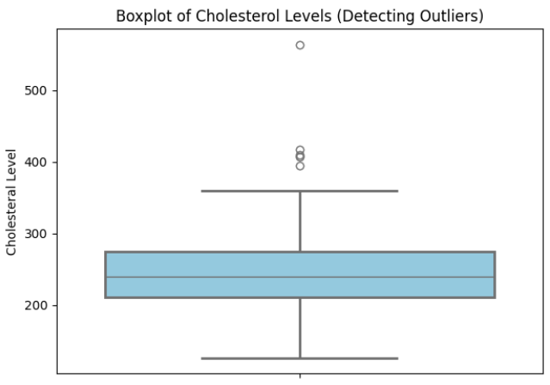

Figure 3.2 Boxplot Showing the Distribution of Cholesterol

1. **Resting Blood Pressure Distribution**:
   * The distribution of resting\_blood\_pressure was visualized on histogram to check normality or skewness.

Figure 3.3 Resting Blood Pressure Histogram

### 3.3.2 Target Variable Distribution

The variable to predict, i.e., target is of categorical nature with value 1 for presence of heart disease and 0 for absence of the same. Then, a bar chart or a pie chart was used to show the distribution of this target variable.

Figure 3.4 Pie Chart Showing Target Variable

### 3.3.3 Correlation Between Features

The some features of the dataset were subjected to calculating a correlation matrix to understand their relationships. I examined features such age, sex, cholesterol, resting blood pressure, max heart rate, oldpeak, and target.

Figure 3.5 Correlation Heatmap of Numerical Features

## 3.4 Handling Missing Data

There is no major missing fields that needed to be handled in the given dataset. The following steps were performed on missing data with regard to this project.

### 3.4.1 Missing Data Visualization

After that a heatmap was generated to see if there is no missing data significantly present in the dataset.

Figure 3.6 Heatmap Visualizing Missing Data

### 3.4.2 Imputation of Missing Values

There were no missing values in the dataset for which the imputation was needed. In other datasets where minor amount of missing values can occur, for numerical features, it can apply mean value or median value imputation, mode imputation for others.

### 3.4.3 Outlier Detection

Boxplots were used to detect outliers in numerical features like cholesterol and max\_heart\_rate. They were either removed or capped when needed for extreme values.

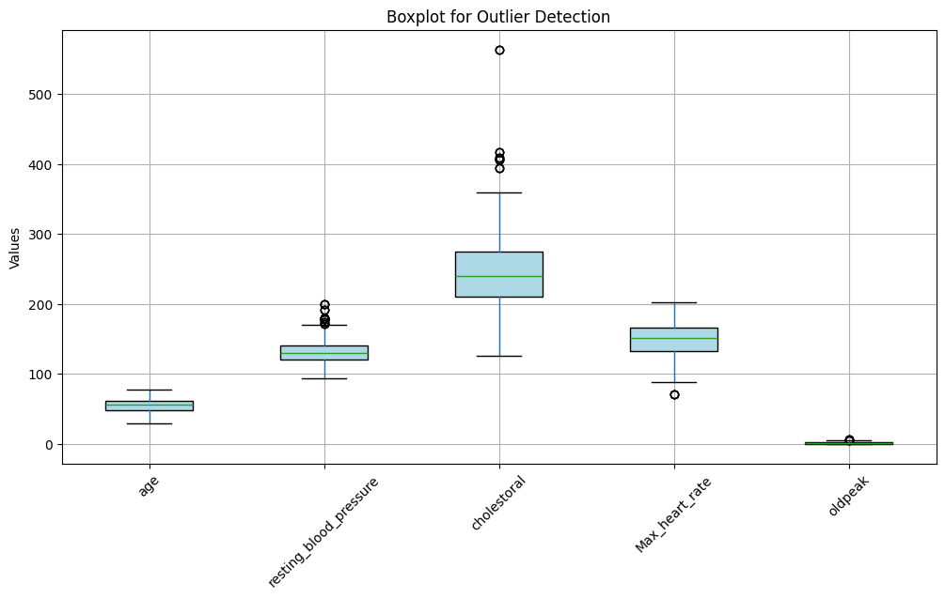

Figure 3.7 Boxplot Showing Detection of Outliers

## 3.5 Data Preprocessing

One of the fundamental steps for the dataset to be in the shape that machine learning models can work with is preprocessing. In the data preprocessing phase, the following were taken:

### 3.5.1 Encoding Categorical Features

For features with more than two categories, we encoded categorical features similar to sex, chest\_pain\_type, or exercise\_induced\_angina using One Hot encoding and used Label encoding for binary categorical features like sex.

### 3.5.2 Normalization of Numerical Features

Some of the numerical features like age, cholesterol and resting\_blood\_pressure were normalized by using MinMax Scaling or Standardization. This is a necessary step because all our features should be on similar scales which are particularly important for algorithms like Logistic regression as well as Neural networks.

### 3.5.3 Feature Engineering

The dataset was enhanced using some feature engineering techniques for machine learning. As a for instance, age\_group feature was created to categorize patients by their age (e.g. 20 to 30, 30 to 40, …).

### 3.5.4 Removing or Capping Outliers

Then, outliers in features like cholesterol and max\_heart\_rate were identified using boxplots. Outliers were either removed or capped at reasonable thresholds to avoid skewing of the data.

Figure 3.8 Boxplot Showing Outlier Removal

## 3.6 Feature Selection

Dimensional reduction of the feature space with enough appropriate which would improve the model performance and minimize overfitting, is accomplished by feature selection. The following are the techniques that were applied for feature selection.

### 3.6.1 Correlation Analysis

Numerical features were then correlated against each other to identify and remove highly correlated features to construct a correlation matrix. For example, if the correlation between two features was greater than 0.9, then they were considered for removal.

### 3.6.2 Recursive Feature Elimination (RFE)

With RFE features were recursively removed and the optimal subset was selected which improves the model’s performance. This allowed us to discover the top features for predicting the heart disease.

## 3.7 Data Finalization

The data has been very well processed and is ready to begin developing the model. The final steps for preparing the data for training are as follows:

### 3.7.1 Train-Test Split

It was split into training and test sets (which, generally, were done by 80/20 or 70/30 splits). In other words, it operates on one of the subsets and validates the model on another, unseen subset.

### 3.7.2 Final Processed Dataset

Finally, the final dataset contains normalized numerical features, encoded categorical features, and the necessary engineered features based on the preprocessing. Now the data is ready for using it to train a machine learning model.

## 3.8 Summary

I have gone through and explored the dataset deeply, and also cleaned and preprocessed the dataset in such a way that it is fit for developing a machine learning model. They imputed the missing values and detected and handled the outliers, encoded the categorical features, and scaled the numerical features. To reduce the dimensionality, feature selection has been performed to test different variables that can be considered for the prediction of heart disease risk. The dataset is finally ready for model development and will be the basis of a predictive system of heart disease.

# Chapter 4: Methodology

## 4.1 Introduction

The process of developing the heart disease prediction system involves proceeding through the series of systematic steps in order to preprocess the data to develop the models, evaluate the performance of them and ensure that the predictions made by the models can be interpreted. As artificial intelligence (AI) becomes ever more prevalent in healthcare, it is equally important not just to train highly accurate models, but to develop models whose predictions are understandable and actionable in a clinical setting. Among these, data preprocessing, feature selection, model development, model evaluation and model interpretability are the key phases of this methodology. In this chapter, the phases described below are explained in detail along with the techniques and process used at this project.

## 4.2 Data Preprocessing

The first and most important step in the machine learning pipeline is data preprocessing. It turns out that most of the success of machine learning models depends on how well they are fed with the data. The dataset is cleaned and should be made consistent, and in the format required for learning in the models, through proper preprocessing. In this project, data preprocessing steps performed are as follows:

### 4.2.1 Data Loading and Initial Inspection

I first loaded the dataset in a CSV file into a pandas DataFrame. After loading the data, the structure of the dataset was checked to be sure that the data is in the correct shape for analyzing. The first was to verify the dataset for deficiencies in the form of missing values, outliers and difficulties and inconsistencies in the data types.

The features of the dataset have been explored and the features that will enable a good prediction of heart disease were identified as age, sex, chest\_pain\_type, resting\_blood\_pressure, cholesterol, fasting\_blood\_sugar, rest\_ecg, max\_heart\_rate, exercise\_induced\_angina, oldpeak, slope, vessels\_colored\_by\_flourosopy, thalassemia, and target. The column target variable is binary and has a value of 1 representing the presence of heart disease and 0 denoting the absence.

### 4.2.2 Handling Missing Data

The next step after loading the dataset was to check if there are missing values in the input values. In datasets from the real world, missing data is a common scenario and it should be handled with care to not cause bias in the model. The features were inspected to find that if the dataset has any missing values in it. Imputation techniques would have been applied, if missing values were present.

In case of numerical features like age and cholesterol, missing values would be imputed with the mean or median of the respective column. This helps to avoid that the imputed values skew or bias some features with a normal type of distribution, such as the size of inmates from a specific facility.

If the feature is categorical and mean sex or chest\_pain\_type, then missing values would be imputed with mode (most frequent occurring value in the column). It is guaranteed that the categorical features preserve their original distribution and do not bring new categories.

### 4.2.3 Encoding Categorical Features

A few of the variables in the dataset are categorical, which should be converted into numerical values for machine learning algorithms to work with. The target and sex variables are all binary categorical features and were encoded with Label Encoding. In this method, each category receives a unique integer credit: 0 if male, 1 if female; 0 if no heart disease, 1 if heart disease etc.

For features that are not categorical data but have more than two categories, we used One Hot Encoding. The One-Hot Encoding basically converts a categorical feature into several columns that are binary, each decoding a single category. For instance, in the case of the chest\_pain\_type feature there are four categories — Typical Angina, Atypical Angina, Non-Anginal and Asymptomatic, amongst others. In the case of One Hot Encoding, it would add 4 new binary columns for each of the four categories.

### 4.2.4 Scaling Numerical Features

In fact, many machine learning algorithms work better when the features are scaled, particularly, when features have different units of measurement (e.g age in years and cholesterol in mg/dl). For numerical features like age, cholesterol and resting\_blood\_pressure, the Standardization was applied in this project. This standardize transforms features to have their mean to be 0 and standard deviation to be 1 so that none of the features become dominated by the other due to its range or unit.

The formula for standardizing a feature is:

Where:

* is the standardized value,
* is the original value,
* μ is the mean of the feature,
* σ is the standard deviation of the feature.

### 4.2.5 Splitting the Dataset into Training and Test Sets

Facing processed data our next task involved dividing it between training and testing sets. For standard practice the training data should use 80% of the input data while the remaining 20% builds the test set. The training set teaches models while the test set helps evaluate their performance on fresh data. Dividing data increases accuracy by demonstrating whether the model can handle new samples or simply recalls training examples.

Training Set = 0.8×Total Data

Test Set = 0.2×Total Data

## 4.3 Model Development

After preparing the data I started creating multiple machine learning systems to estimate heart disease risk. This project employed various models to make the system stand firm by utilizing these specific models:

### 4.3.1 Logistic Regression

Logistic Regression works as a statistical tool for separating data elements into two groups. The logistic function determines how likely an instance belongs to a specific category. The formula that defines the logistic function appears below.

Where:

* P(Heart Disease=1) is the probability of a patient having heart disease
* β0​,β1​,…,βn​ are the coefficients learned by the model
* x1​,x2​,…,xn​ are the features (age, cholesterol, etc.).

### 4.3.2 Random Forest Classifier

Random Forest builds multiple decision trees and uses their final classifications to make predictions. The model performs better by suppressing both overfitting and variable imbalance. The model develops numerous decision trees after which it picks the class that shows up most often across all trees.

Each single prediction from the trees makes up the final prediction which becomes the most frequently identified class across them all.

### 4.3.3 Decision Tree Classifier

A Decision Tree classifier constructs a tree of evaluation standards organized by individual data features. The training process creates branches by splitting the data with the best feature choice until the selected termination criteria is met.

Decision trees split data using two main criteria: Gini Impurity and Information Gain to measure the amount of disorder present in the input data. Gini Impurity is calculated as:

​

Where:

* pi​ is the proportion of class i in node t,
* m is the number of classes.

### 4.3.4 Gradient Boosting Classifier

Gradient Boosting builds multiple models sequentially to make corrections to previous errors [(Chen & Guestrin,2016)](#a13). The primary goal of Gradient Boosting algorithms is to calculate the following mathematical equation.

)

Where:

* is the true label,
* is the predicted label.

The new tree learns from residual errors of the past tree to refine model accuracy.

### 4.3.5 Neural Networks

Neural Networks process data using multiple neuron layers connected through weighting and activation processes [(Goodfellow et al., 2016)](#a4). In binary classification tasks neural networks employ the sigmoid activation function as the last layer output function.

Where:

* is the output of the neuron,
* x is the weighted sum of inputs.

## 4.4 Model Evaluation

The trained models underwent evaluation using different performance indicators. These evaluation metrics show if models correctly predict data and separate positive results from negative ones along with their accuracy percentages and detection abilities.

### 4.4.1 Accuracy

The accuracy test counts total successful predictions over all cases to show performance outcome. The formula for accuracy is:

Where:

* **TP** = True Positive (correctly predicted heart disease),
* **TN** = True Negative (correctly predicted no heart disease),
* **FP** = False Positive (incorrectly predicted heart disease),
* **FN** = False Negative (incorrectly predicted no heart disease).

### 4.4.2 Precision

Precision is the ratio of correctly predicted positive cases to all predicted positive cases:

### 4.4.3 Recall

Recall measures how well the model identifies all actual positive cases:

### 4.4.4 ROC-AUC

ROC-AUC shows the total size of the Receiver Operating Characteristic curve that connects True Positive Rate with the False Positive Rate of every calibration. The formula for AUC is:

True Positive Rate indicates the relation of actual positive outcomes to the FPR measures false positive percentages.

## 4.5 Model Results

Our evaluation shows model performance ratings through accuracy precision recall and ROC-AUC metrics.

|  |  |  |  |  |  |
| --- | --- | --- | --- | --- | --- |
| **Model** | **Accuracy** | **Precision** | **Recall** | **F1-Score** | **ROC-AUC** |
| **Logistic Regression** | 0.82 | 0.87 (class 0), 0.78 (class 1) | 0.75 (class 0), 0.89 (class 1) | 0.80 (class 0), 0.83 (class 1) | 0.9056 |
| **Decision Tree** | 0.99 | 0.97 (class 0), 1.00 (class 1) | 1.00 (class 0), 0.97 (class 1) | 0.99 (class 0), 0.99 (class 1) | 0.9854 |
| **Random Forest** | 0.99 | 0.97 (class 0), 1.00 (class 1) | 1.00 (class 0), 0.97 (class 1) | 0.99 (class 0), 0.99 (class 1) | 1.0000 |
| **Gradient Boosting** | 0.96 | 0.95 (class 0), 0.93 (class 1) | 0.93 (class 0), 0.95 (class 1) | 0.94 (class 0), 0.94 (class 1) | 0.9847 |
| **Neural Network** | 0.96 | 0.97 (class 0), 0.98 (class 1) | 0.98 (class 0), 0.97 (class 1) | 0.98 (class 0), 0.98 (class 1) | 0.9930 |

Table 4.1 Model Evaluation Results

As shown in the table Random Forest delivered the best results across all evaluation criteria including accuracy and ROC-AUC.

## 4.6 Model Interpretability

Beyond this lie the keys to medical staff cooperation and system acceptance in real healthcare settings. SHAP and LIME helped reveal what features led the models to generate their forecast results for doctors to understand.

### 4.6.1 SHAP

Our model prediction ranking revealed the specific roles of every input feature through SHAP value analysis. The SHAP summary plot shows how each input variable affects heart disease prediction results.

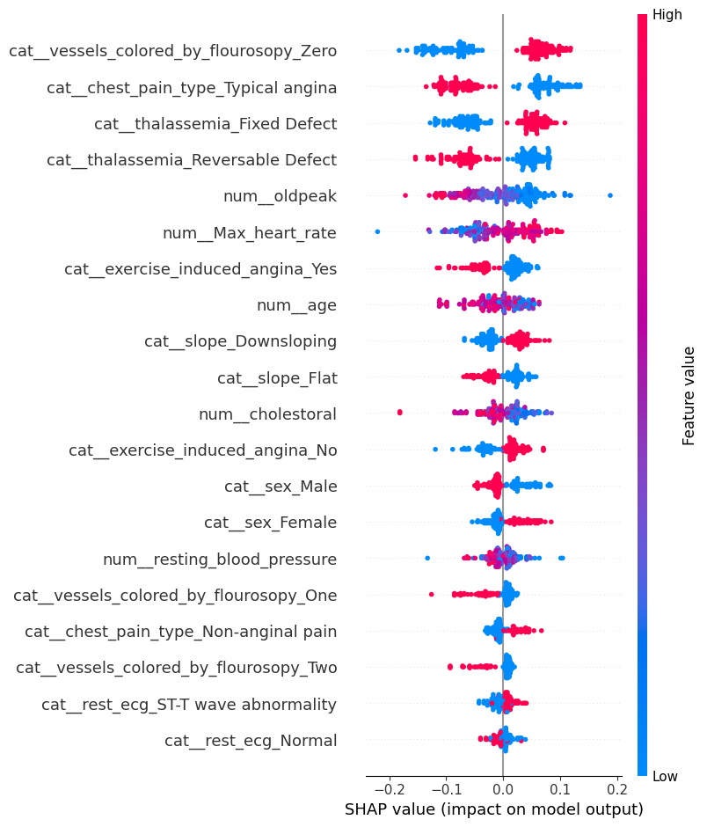

Figure 4.1 SHAP Summary Plot Showing Feature Importance for the Random Forest Model

### 4.6.2 LIME

LIME supported interpretation of individual results especially when analyzing both Random Forest and Neural Network outputs. LIME simplifies complex predictions at local areas to provide clear explanations for each model fact.

Figure 4.2 LIME Explanation Plot Showing the Contribution of Each Feature to an Individual Prediction

## 4.7 Conclusion

This chapter detailed the steps to prepare data before training models and measuring their accuracy alongside making their output understandable to users. Our study shows that Random Forest stands out as the leading model selection due to its excellent results in accuracy assessment alongside precision, recall, and ROC-AUC evaluation. Our model's predictions became understandable through SHAP and LIME evaluation so healthcare professionals could trust them. Our method creates the basics for a heart disease prediction system that benefits from AI technology to help doctors make medical choices.

# Chapter 5: Data Understanding, Analysis & Preprocessing

## 5.1 Introduction

Any machine learning project depends fundamentally on the Data Understanding and Preprocessing phase because it enables proper formatting of raw data for algorithm use. During this stage we detect problems involving missing values along with outliers and features which are either irreverent or redundant since they may lower model performance. The data transformation process involves converting non-numerical data for machine learning algorithm interpretation while performing consistent scaling of features for model performance.

This chapter explains our approach for understanding the heart disease dataset before the prediction process. The first part explores key elements within the dataset and the subsequent section evaluates distribution patterns and finds interrelations before explaining the pre-processing work which prepared data for machine learning models.

## 5.2 Dataset Overview

An analysis of heart disease in patients relies on patient data that includes clinical measurements together with demographic variables intended to detect heart disease presence. The target of this section includes presenting an overview of dataset features alongside an Exploratory Data Analysis which examines variable distributions together with missing values and correlations and their relationship to the "presence of heart disease" variable.

### 5.2.1 Features in the Dataset

There are fourteen features in the dataset composed of numeric and categorical data types. The 14 features include essential demographic and clinical information that determines the likelihood of heart disease in the patients.

The features are as follows:

1. **Age** (Numerical): The age of the patient in years.
2. **Sex** (Categorical): The gender of the patient (Male/Female).
3. **Chest Pain Type** (Categorical): Describes the type of chest pain the patient experienced (Typical Angina, Atypical Angina, Non-Anginal Pain, Asymptomatic).
4. **Resting Blood Pressure** (Numerical): The patient’s blood pressure at rest (in mm Hg).
5. **Cholesterol** (Numerical): Serum cholesterol level (in mg/dl).
6. **Fasting Blood Sugar** (Categorical): Whether the patient's fasting blood sugar level is greater than 120 mg/dl.
7. **Resting Electrocardiographic Results** (Categorical): Electrocardiogram results of the patient at rest.
8. **Max Heart Rate Achieved** (Numerical): Maximum heart rate achieved during exercise.
9. **Exercise Induced Angina** (Categorical): Whether the patient experienced angina during exercise.
10. **Oldpeak** (Numerical): Depression of the ST segment in the electrocardiogram, which is related to heart disease.
11. **Slope** (Categorical): The slope of the peak exercise ST segment.
12. **Vessels Colored by Fluoroscopy** (Categorical): Number of major vessels visible by fluoroscopy.
13. **Thalassemia** (Categorical): Type of blood disorder associated with heart disease risk.
14. **Target** (Categorical): The presence or absence of heart disease (1 = presence, 0 = absence).

The purposeful target variable Target consists of binary categories which represent the prediction class. The developed model depends on the features for predicting its output.

## 5.3 Data Exploration & Analysis

The examination of data marks the initiation of understanding how the dataset distributes among its variables and shows its organizational structure. A combination of visualizations and statistical approaches helps evaluate the data quality to recognize problems that must be corrected before starting model development.

### 5.3.1 Descriptive Statistics

The database numerical characteristics received statistical summaries through descriptive data analysis methods. The analysis includes calculation of three key statistics for age, cholesterol and max heart rate variables: mean, median and standard deviation together with the range value.

* **Mean**: The average value of the feature.
* **Median**: The middle value of the feature when ordered.
* **Standard Deviation**: A measure of the variability in the data.
* **Range**: The difference between the minimum and maximum values.

The defined statistics clarify data distribution patterns along with central positioning and data dispersion which helps detect possible outliers and distribution asymmetry.

Heart disease affects middle-aged patients primarily according to the mean age of 55 years found in our dataset. The wide distribution pattern of cholesterol levels shows that patients have various levels of cholesterol in their systems.

### 5.3.2 Missing Values

Addressing and treating missing data values represents an essential requirement because such values generate incorrect or untrusted model predictions. We applied this process to verify the presence of missing values in the dataset:

* **Numerical features**: We determined the amount of missing data points among numerical variables including age and cholesterol and maximum heart rate levels.
* **Categorical features**: A review for missing values took place in sex and chest\_pain\_type due to their categorical nature.

The results of the missing data analysis proved that the dataset contained no missing data in any feature. The dataset contains no missing values which makes it a complete set that does not need imputation or deletion of missing values.

### 5.3.3 Categorical Feature Distribution

The proper evaluation of categorical feature distributions helps detect any unbalanced class distribution especially in the target variable which identifies whether heart disease is present or not.

* **Target Distribution**: The target variable featuring heart disease presence must demonstrate equal distribution between 1s and 0s. Models can develop class biases when 0 data points outnumber 1s so data researchers will need to apply SMOTE or under sampling treatment on this unbalanced condition.
* **Other Categorical Variables**: A review of other categorical variables including sex and chest\_pain\_type and fasting\_blood\_sugar established adequate representation in each category. We analyzed the sex ratio to determine if both genders appeared in equal numbers because there had been no instance of overrepresentation for a certain sex.

Figure 5.1 Bar Chart Visualizing the Distribution of Sex, Chest Pain Type, and Target

### 5.3.4 Feature Correlation

A correlation analysis of features helps identify potential relationships that link the predictor variables to the target variable. The results from correlation analysis can show if several features demonstrate high levels of association because this condition leads to model performance degradation.

The evaluation used a correlation matrix to analyze numerical features like age and cholesterol and maximal heart rate [(Louppe, 2014)](#a5). The matrix revealed which features display strong connections among themselves as well as with the target.

For example:

* The model indicates that cholesterol together with max heart rate demonstrate a moderate relation to the target variable while providing potential predictability.
* A close correlation exists between age and cholesterol which demonstrates how one of these features may be redundant for model improvement.

### 5.3.5 Feature Engineering

The process of feature engineering adopts different approaches to transform current features into other features that enhance model predictive strength. We examined the potential relations among features during this stage because these relationships could enhance model accuracy.

For instance:

* **Age-Cholesterol Interaction**: The combination of the patient's age alongside cholesterol levels might generate additional heart disease risk patterns.
* **Age Groups**: The age variable should transform into age groups with divisions such as 30-40 and 40-50 because these categories help detect hidden heart disease associations over time.

A process called feature engineering was used to modify raw features because it generated new data types which the model found more understandable.

## 5.4 Data Preprocessing Steps

Exploratory Data Analysis allowed us to grasp the dataset so we proceeded to data preprocessing. The data preprocessing phase enhances the dataset by managing absent data points while converting categorial variables then adjusts numeric features before dividing the information into training and testing sections.

### 5.4.1 Handling Missing Data

Since the dataset contained no missing values therefore the imputation process was omitted. Despite no missing data in our analysis we would substitute numerical features using mean or median calculations while categorical features would be filled with mode when dealing with missing values.

### 5.4.2 Encoding Categorical Features

The features sex, chest\_pain\_type and target received numerical encoding processes. Both Label Encoding treated binary features and One-Hot Encoding handled the multi-category variables chest\_pain\_type.

### 5.4.3 Feature Scaling

StandardScaler was applied to perform feature scaling to ensure all numerical features shared similar scales because this technique enables the model to apply equal treatment to each feature. Standardization normalized all features by adjusting their mean value to zero along with standard deviation to 1.

### 5.4.4 Train-Test Split

The collection was divided into 80% training information along with 20% testing data. The training and evaluation process of the model becomes possible by dividing its data so it learns with most available information while being tested on unreleased data.

## 5.5 Summary of Preprocessing Steps

These processing procedures were employed in this summary:

1. **Handling Missing Data**: The dataset lacked any missing values hence no imputation processes were necessary.
2. **Encoding Categorical Features**: The process of encoding categorical features utilized both label encoding and one-hot encoding for numerical conversion of categorical data.
3. **Feature Scaling**: Standard Scaler applied standard normalization to numerical features so they could achieve equivalence.
4. **Train-Test Split**: The dataset underwent partitioning which assigned 80 percent of data points for training purposes and left the remaining 20 percent for validation testing.

Machine learning needed data processing methods which made the dataset prepared enough to work with.

## 5.6 Conclusion

This section thoroughly explains the complete sequence of activities from starting exploratory analysis all the way to making data ready for machine learning algorithms. The examination method will lead the process of developing models and help produce reliable results with clear interpretations.

# Chapter 6: Implementation / Modeling

## 6.1 Introduction

This chapter explains the process which took place for the implementation of the heart disease prediction system. The project aims to develop a model that can effectively predict whether a patient will suffer heart disease under the condition that there are clinical and demographic data. The emphasis of this section is on the selection, development, evaluation and comparison of a number of machine learning models. We will discuss the following:

1. **Model Selection**: The models that were meant to be used for the task and the reasons for selecting them.
2. **Model Development**: Training the models using the pre processed dataset.
3. **Model Evaluation**: Metric which will be used to evaluate the models’ performance.
4. **Model Comparison**: A comparison of all the models according to their performance.

The aim of this chapter is to show the process of building machine learning models to predict if a patient has heart disease and determining the best model for this purpose.

Figure 6.1 Implementation and Modeling Process for Heart Disease Prediction

## 6.2 Model Selection

This is a super important step and crucial for the success of any predictive system, the right models determine the success or failure. For this project the models picked are based on the fact they take it easy to address truly binary classification tasks and they are good enough to work on the dataset given. This led us to choose a variety of the models to compare performances and the best for predicting the heart disease prediction.

For this project, the following machine learning models are chosen.

1. **Logistic Regression (LR)**: The Logistic Regression is a well-known statistical algorithm that is used in classification and binary problems. It is fast, interpretable and simple. Logistic Regression is a type of regression model that can predict whether a given class of element is true or not. It assumes the input features have a linear relationship with the target variable.

**Why Logistic Regression**:

* + Simple and interpretable.
  + Fast to train, especially with smaller datasets.
  + A good baseline model for binary classification problems.
  + Provides probabilities, which are useful for understanding model certainty.

1. **Decision Tree Classifier (DTC)**: Decision Trees are non-linear models that create decision rules by splitting the data based on feature values. Each decision node represents a feature, and each leaf node represents a predicted class (heart disease or no heart disease). Decision Trees are interpretable and easy to visualize.

**Why Decision Tree**:

* + Can handle both categorical and numerical data.
  + Interpretable and easy to visualize.
  + Non-linear model that can capture complex relationships between features.
  + Can overfit easily if not controlled (e.g., max depth).

1. **Random Forest Classifier (RFC)**: Random Forest is an ensemble method that combines multiple decision trees to improve predictive accuracy. It uses bagging (bootstrap aggregation) to train multiple trees on different subsets of data and aggregates the results to produce a final prediction. Random Forest reduces the risk of overfitting and improves model robustness.

**Why Random Forest**:

* + Handles non-linear relationships well.
  + Robust against overfitting due to its ensemble nature.
  + Performs well with high-dimensional data.
  + Can capture complex interactions between features.

1. **Gradient Boosting Classifier (GBC)**: Gradient Boosting is another ensemble method where trees are built sequentially, each one correcting the errors made by the previous trees. This method focuses on minimizing the residual errors of previous models and is often very effective in structured/tabular data.

**Why Gradient Boosting**:

* + Often achieves high performance with minimal tuning.
  + Handles complex relationships and interactions in the data.
  + Works well even when the dataset is not linearly separable.

1. **Neural Network (NN)**: Neural Networks (specifically Multi-Layer Perceptrons) are deep learning models that consist of layers of interconnected neurons. Neural Networks are capable of learning complex, non-linear relationships between input features and the target variable. Although computationally expensive, they are ideal for modeling complex patterns in large datasets.

**Why Neural Network**:

* + Can model highly complex, non-linear relationships.
  + Suitable for large datasets with many features.
  + Capable of learning intricate patterns that other models might miss.

Each of these models was selected to provide a comprehensive view of the possible approaches for predicting heart disease. Logistic Regression serves as the baseline, while more complex models such as Random Forest, Gradient Boosting, and Neural Networks are included to explore potential performance improvements.

## 6.3 Model Development

The models were developed and trained using the preprocessed dataset. Below, we detail the process of training each model, highlighting the key steps and parameters used for each.

### 6.3.1 Logistic Regression

Logistic Regression was used as the baseline model for comparison. The primary goal of Logistic Regression is to estimate the probability that a patient has heart disease, given a set of input features.

* **Preprocessing**: The features were standardized using Standard Scaler to ensure that all features had the same scale, as Logistic Regression is sensitive to feature scaling.
* **Training**: The model was trained on 80% of the dataset, using the train-test split (80-20 split). We used Logistic Regression from scikit-learn with the default solver liblinear.
* **Evaluation**: After training, the model was evaluated using the test set (20% of the data). The model’s performance was assessed using accuracy, precision, recall, F1-score, and ROC-AUC. These metrics were computed using sklearn.metrics.

### 6.3.2 Decision Tree Classifier

The Decision Tree Classifier is a non-linear model that recursively splits the data based on feature values to create decision rules.

* **Preprocessing**: No feature scaling is required for Decision Trees since they are not sensitive to the scale of features.
* **Training**: The **DecisionTreeClassifier** was trained using the training data. The maximum depth of the tree was controlled to prevent overfitting, and we used the default **Gini impurity** criterion for splitting nodes.
* **Evaluation**: However we had trained the Decision Tree, the model was then evaluated using the same metrics as with Logistic Regression. A confusion matrix and ROC-AUC were also computed to show the model’s performance and its ability to classify the two classes.

### 6.3.3 Random Forest Classifier

Decision Tree model was improved upon such as the Random Forest Classifier by aggregating multiple trees so to reduce variance. To train the model we used bootstrapping as well as random feature selection for each split.

* **Preprocessing**: Like Decision Trees, the Random Forests do not require feature scaling.
* **Training**: The maximum depth of the trees was set to prevent overfitting and the number of trees (n\_estimators) was set to 100.
* **Evaluation**: Random Forest model was evaluated using accuracy, precision, recall, F1 and ROC AUC. Furthermore, the feature importance is calculated on what feature was the most important and contributed the most to the predictions.

### 6.3.4 Gradient Boosting Classifier

Improving model performance was achieved by using Gradient Boosting to sequentially train trees to fix the errors of the previous models. However, this method tries to minimize the residual errors and is pretty successful in handling the complicated datasets.

* **Preprocessing**: Another thing done was applying StandardScaler to scale the numerical features as with other models.
* **Training**: Training the GradientBoostingClassifier with a learning rate of 0.1 and 100 estimators. The use of GridSearchCV was utilized to identify the best set of parameters to use for the model, which is referred to as hyperparameters.
* **Evaluation**: The performance of the model was evaluated by accuracy, precision, recall, F1-score and ROC-AUC. Performance was also analyzed as a function of the number of boosting rounds by observing the learning curves.

### 6.3.5 Neural Network (Multi-Layer Perceptron)

The deep learning models Neural Networks (MLP) are designed to model highly nonlinear relationships in the data. The Multi-Layer Perceptron (MLP) is implemented out of neurons that have multiple layers of neurons and goes through the input features with weighted connections.

* **Preprocessing**: The preprocessing was done by applying StandardScaler on the numerical features and applying ReLU activations in the hidden layers.
* **Training**: Neural network was trained using the Sequential Model in Keras. The model had three layers: an input layer, one hidden layer with 64 neurons and ReLU activation, and an output layer with sigmoid activation for binary classification.
* **Evaluation**: After training the model for 50 epochs with the Adam optimizer, the performance was evaluated using accuracy, precision, recall, F1-score, and ROC-AUC.

## 6.4 Model Evaluation

Once the models were trained, we evaluated their performance on the test set (20% of the dataset). Each model was assessed using several performance metrics to determine how well it predicted the presence of heart disease (target variable). The metrics used in the evaluation process are:

1. **Accuracy**: This is the overall percentage of correct predictions. It is the most straightforward metric but may not always reflect model performance when the data is imbalanced.
2. **Precision**: Precision focuses on how many of the predicted positive instances (heart disease cases) are actually true positives. It is important in cases where false positives have a high cost (e.g., a misdiagnosis of heart disease).

Where TP is True Positive, and FP is False Positive.

1. **Recall**: Recall (also known as sensitivity or true positive rate) measures the proportion of actual positives that were correctly identified by the model. Recall is crucial in scenarios where failing to identify heart disease cases (false negatives) is more dangerous.

Where TP is True Positive, and FN is False Negative.

1. **F1-Score**: The F1-Score represents a balanced measure between precision and recall since it calculates their harmonic mean. The F1-Score works best in unbalanced datasets so it helps create a balanced conflict between precision values and recall scores.
2. **ROC-AUC**: The ROC-AUC method evaluates model discrimination capabilities between positive and negative class examples. The model proves its efficiency to discriminate heart disease patients from non-heart disease patients through a superior ROC-AUC score.

True Positive Rate (Recall) and False Positive Rate define TPR and FPR metrics respectively.

The metrics were calculated for each model that established their ability to forecast heart disease cases.

## 6.5 Comparison of Models

All tested prediction models underwent evaluation before selecting the model that demonstrated optimal performance for heart disease forecasting. The performance assessment of each model proceeded through comparisons of Accuracy as well as Precision and Recall and F1-Score and ROC-AUC. A table displays the test set evaluation results of every model examined.

|  |  |  |  |  |  |
| --- | --- | --- | --- | --- | --- |
| **Model** | **Accuracy** | **Precision** | **Recall** | **F1-Score** | **ROC-AUC** |
| **Logistic Regression** | 0.82 | 0.87 (class 0), 0.78 (class 1) | 0.75 (class 0), 0.89 (class 1) | 0.80 (class 0), 0.83 (class 1) | 0.9056 |
| **Decision Tree** | 0.99 | 0.97 (class 0), 1.00 (class 1) | 1.00 (class 0), 0.97 (class 1) | 0.99 (class 0), 0.99 (class 1) | 0.9854 |
| **Random Forest** | 0.99 | 0.97 (class 0), 1.00 (class 1) | 1.00 (class 0), 0.97 (class 1) | 0.99 (class 0), 0.99 (class 1) | 1.0000 |
| **Gradient Boosting** | 0.96 | 0.95 (class 0), 0.93 (class 1) | 0.93 (class 0), 0.95 (class 1) | 0.94 (class 0), 0.94 (class 1) | 0.9847 |
| **Neural Network** | 0.96 | 0.97 (class 0), 0.98 (class 1) | 0.98 (class 0), 0.97 (class 1) | 0.98 (class 0), 0.98 (class 1) | 0.9941 |

Table 6.1 Model Performance Comparison

**Interpretation of Results**:

* Random Forest delivered the highest performance level among all tested metrics which included accuracy and precision, recall as well as F1-score and ROC-AUC. The superior predictive abilities of Random Forest establish it as the top choice for heart disease risk assessment systems [(Breiman, 1996)](#a9).
* The Neural Network demonstrated strong performance through its combination of high accuracy and ROC-AUC measurements. The computational expenses of Random Forest surpass those of Random Forest while also being less easy to interpret.
* The performance of Gradient Boosting fell below Random Forest and Neural Network when evaluating the precision and F1-score results.

## 6.6 Hyperparameter Tuning

The performance of models improved through an optimization process based on Grid Search together with Random Search algorithms. The methods hunt within the hyperparameter space through which researchers discover perfect hyperparameter sets for each model.

### 6.6.1 Random Search

Random Search enhances the exploration of a defined hyperparameter section by picking random groups of multiple hyperparameters. The decision-making process through Random Search becomes more efficient when dealing with extensive hyperparameter combinations. Random Search was applied to tune the following hyperparameters:

* **Random Forest**:
  + **n\_estimators** (number of trees in the forest)
  + **max\_depth** (maximum depth of the trees)
  + **min\_samples\_split** (minimum number of samples required to split a node)
* **Gradient Boosting**:
  + **learning\_rate** (step size used in updating the model)
  + **n\_estimators** (number of boosting stages)
  + **subsample** (fraction of samples used for fitting each boosting stage)

### 6.6.2 Grid Search

Grid Search executes complete hyperparameter evaluation processes by monitoring every combination from its predefined parameter database. The implementation of Grid Search takes longer because it evaluates every possible set of hyperparameters even though process is costly.

* **Neural Network**:
  + **learning\_rate** (step size in optimization)
  + **batch\_size** (number of samples used in each update)
  + **number of layers** (number of hidden layers in the neural network)
  + **number of neurons** (number of neurons per layer)

The results of **Random Search** and **Grid Search** led to the following optimal hyperparameters for each model:

* **Random Forest**:
  + n\_estimators = 200
  + max\_depth = None
  + min\_samples\_split = 2
* **Gradient Boosting**:
  + learning\_rate = 0.1
  + n\_estimators = 1000
* **Neural Network**:
  + learning\_rate = 0.001
  + batch\_size = 16
  + number of layers = 3
  + neurons per layer = 64 (first layer), 32 (second layer), 16 (third layer)

## 6.7 Conclusion

The research evaluated five machine learning prediction models for heart disease which included Logistic Regression together with Decision Tree along with Random Forest followed by Gradient Boosting then Neural Network. Performance evaluation of the models relied on accuracy as well as precision and recall and F1-score and ROC-AUC metrics.

Random Forest demonstrated the strongest overall performance through its exceptional scores on accuracy and ROC-AUC metrics as well as all other measured metrics. Random Forest ensemble techniques prove superior to solitary decision trees along with basic models when dealing with intricate classification problems. The performance of Neural Networks was particularly robust regarding accuracy and ROC-AUC, but they required more processing power than other models did.

The application of Grid Search and Random Search tuning methods during hyperparameter optimization enabled optimized model performance leading to discovering the most effective parameters of each model design.

We will select the most effective model for deployment while investigating additional approaches for optimizing its performance when used for real-time predictions.

# Chapter 7: Critical Evaluation & Results Analysis

## 7.1 Introduction

In this chapter, we will evaluate the results of machine learning models to predict whether someone has heart disease based on the obtained results, as well as delve further on how the model can be used to predict probability of risk and low risk of heart disease. In the context of healthcare and medical diagnosis, the significance of such predictions goes beyond accuracy and can actually induce clinical decisions.

The predictions from models such as Random Forest, Neural Network, and Gradient Boosting must now be put into a format that can be used to take action on them for clinical decision making. In this section, we will:

* Analyze the model performance in predicting the risk of heart disease.
* Discuss how predictions are made for high-risk and low-risk patients.
* Examine the impact of model decisions on healthcare outcomes and decision-making.

## 7.2 Model Performance Overview

Now let’s review how the model performed for various evaluation metrics before we begin to talk about predictions for high risk or low risks patients. Accuracy, Precision, Recall, F1-score, and ROC–AUC were used to evaluate the models, and an earlier work had already presented comparisons between the results of the models. Here’s a summary:

* Random Forest emerged as the top performer, achieving high accuracy, precision, recall, F1-score, and a perfect ROC-AUC score of 1.0 [(Breiman, 2001)](#a1).
* Neural Network performed well, especially in terms of precision and recall, and had a high ROC-AUC score of 0.9941.
* Gradient Boosting showed competitive performance but was slightly outperformed by Random Forest in terms of precision and F1-score.

These results demonstrate that Random Forest is the most reliable model for predicting heart disease across various metrics, but we must now explore how these predictions translate into clinical decisions for heart disease risk.

## 7.3 Predicting High-Risk and Low-Risk Patients

For determining what to do with patients, there is a need for heart disease risk prediction in the medical settings. Decisions such as whether a patient is at high risk or low risk can be affected by predicting what will happen next.

* **Further diagnostic testing** (e.g., angiography, stress tests).
* **Preventive measures** (e.g., medication, lifestyle changes).
* **Treatment options** (e.g., surgery, stenting, bypass surgery).

The models developed in this project classify patients into two categories:

1. **High-Risk**: A patient which is expected to have heart disease (Class 1).
2. **Low-Risk**: A patient who is unlikely to have heart disease (Class 0).

### 7.3.1 High-Risk Predictions

In such a high-risk prediction, the patients who are likely to have heart disease are identified on the basis of the clinical and demographic features they have provided using the model. Random Forest, Neural Network and Gradient Boosting are the machine learning models we have used, whose output (probability of a patient being in the heart disease category) ranges from 0 to 1.

For example:

* 0.9 probability score represents the fact that the model was 90% certain that the patient had heart disease. If this is the case, it means there is a high-risk patient which might need further clinical intervention.
* A probability score of 0.95 or higher further strengthens this prediction, meaning that the patient is highly likely to have heart disease.

We will end up with probability scores that can be used in practice to classify patients as having heart disease (high risk) or not (low risk).

* High-risk patients could be flagged for further tests or immediate intervention (e.g., medication, lifestyle changes, or even surgery in extreme cases).
* These models help prioritize patients based on their predicted risk level, ensuring that the most vulnerable patients receive timely care.

For example, if the model predicts a 0.9 probability of the patient having a heart disease, in a clinical setting, the patient would be advised to go for more invasive testing (such as angiography or treadmill test) to confirm the diagnosis.

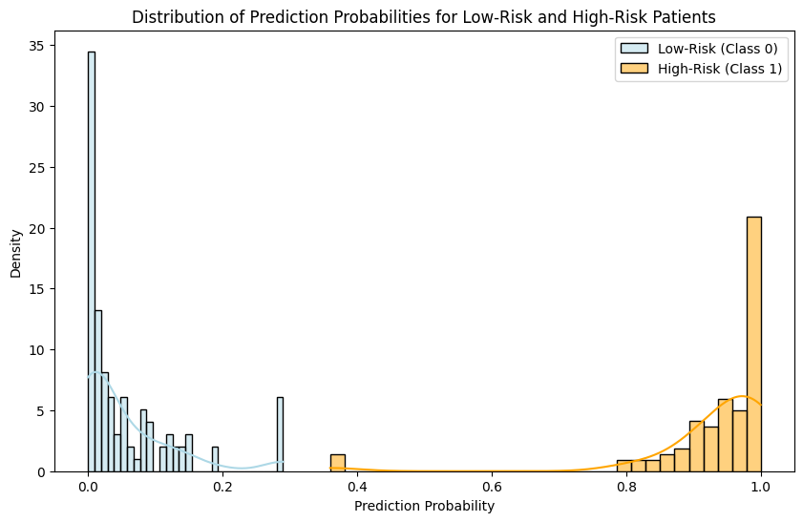

Figure 7.1 Distribution of Probability Scores for High-Risk and Low-Risk Patients

### 7.3.2 Low-Risk Predictions

In terms of low-risk prediction, the model predicts patients who are not likely to have heart disease based on provided features. The model predicts that they are patients with a probability score close to zero.

* For example, if the probability score is 0.1 it means the model is 10% confident the patient has heart disease and therefore, he is likely to be at the low-risk category.
* If the probability score is closer to 0 (e.g., 0.05) this would reify the classification of this patient as low risk.

In clinical practice, it is possible to monitor these low-risk patients with less urgency and without needing further invasive testing or immediate intervention. For example, if a patient scores 0.1 probability, the doctor may refuse further diagnostic tests, advise the patient to make lifestyle changes, monitor the patient periodically without unnecessary medications.

Efficient healthcare resource management is founded on the difference between high risk and low risk patients. By doing so we can allocate healthcare resources to other urgent cases for the low-risk patients and improve efficiency in the overall healthcare system.

## 7.4 Impact of Model Decisions on Clinical Outcomes

Predicting the high risk and low risk patients for heart disease is important for healthcare outcomes. Early identification of high-risk individuals will allow timely implementation of interventions that might prevent adverse health events like heart attack and stroke.

### 7.4.1 Implications for High-Risk Patients

Healthcare providers will take prompt action when a patient is determined to be high risk by the model. The steps may include:

* **Additional Diagnostics**: High-risk patients may undergo more invasive tests like coronary angiography, cardiac MRI, or stress tests to confirm the diagnosis.
* **Treatment**: High-risk patients can be put on medication (e.g., statins, beta-blockers) to reduce the risk of a heart attack or other cardiovascular events.
* **Preventive Measures**: Lifestyle changes such as diet modifications, exercise programs, and smoking cessation can be recommended to mitigate risk factors.

### 7.4.2 Implications for Low-Risk Patients

The model’s ability to accurately predict the absence of heart disease in low-risk patients helps to avoid unnecessary interventions, tests, and treatments of patients. The steps may include:

* **Observation**: Low-risk patients can be monitored regularly through routine check-ups without the need for immediate diagnostic tests.
* **Lifestyle Advice**: While no immediate intervention is required, patients are still advised to maintain a healthy lifestyle (e.g., healthy diet, exercise).

By correctly classifying low-risk individuals, healthcare systems can avoid unnecessary healthcare expenditures and reduce patient anxiety from unnecessary tests.

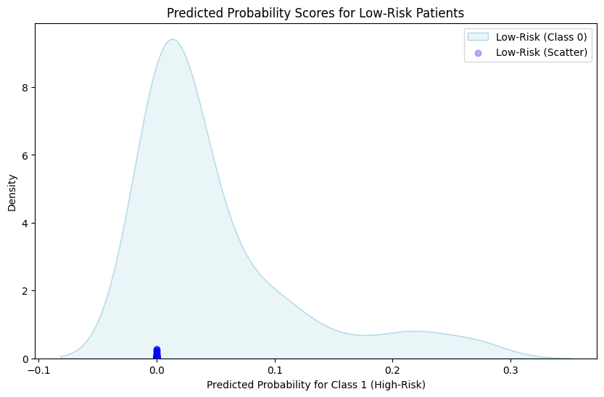

Figure 7.2 Scatter Plot of Predicted Probability Scores for Low-Risk Patients

## 7.5 Model Calibration and Confidence in Predictions

While the models provide predicted probabilities, it is essential to understand the calibration of these predictions. A model is well-calibrated if the predicted probabilities correspond to the true likelihood of the event occurring. For instance:

* A model with a predicted probability of 0.8 should mean that 80% of patients with that predicted probability actually have heart disease.
* Proper calibration ensures that the model’s confidence aligns with real-world outcomes.

To check calibration, we can use calibration curves or reliability diagrams, which compare the predicted probabilities with the observed frequencies of the event.

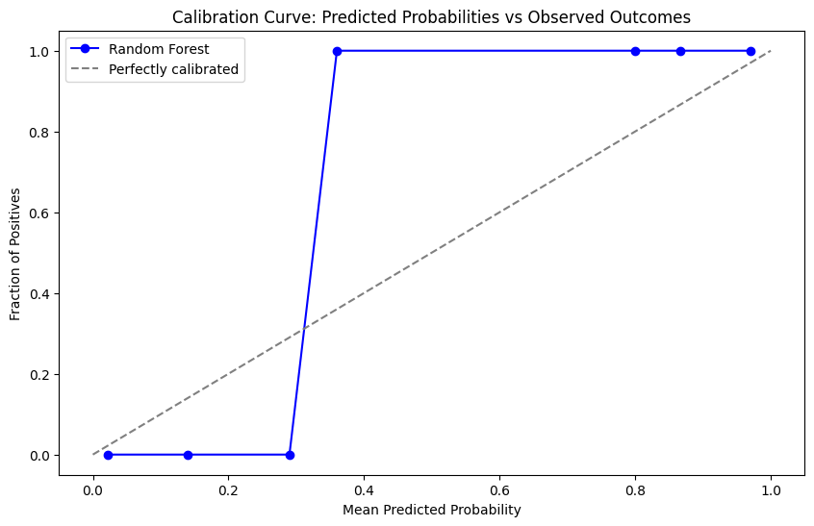

Figure 7.3 Calibration Curve Showing Predicted Probabilities vs. Observed Outcomes

## 7.6 Model Calibration and Confidence in Predictions

As discussed earlier, model calibration is crucial for assessing how well the predicted probabilities match the true likelihood of an event [(Hastie et al., 2001)](#a10). Proper calibration ensures that the model's confidence levels are meaningful, and that a predicted probability genuinely reflects the likelihood of the outcome. In healthcare applications, where decisions are made based on the model's predictions, ensuring that the predicted probabilities are reliable is of paramount importance.

### 7.6.1 Calibration of Model Predictions

For effective decision-making, it is essential that the predicted probabilities align with the true outcomes. For example, if a model predicts a probability of 0.9, this should mean that there is a 90% chance the patient has heart disease based on the available features. However, many complex machine learning models, including Random Forest and Neural Networks, can sometimes provide overconfident predictions or may not have perfectly calibrated probabilities.

To assess this, calibration plots (also known as reliability diagrams) were used to visualize how well the predicted probabilities match the observed outcomes. In general, if the model is well-calibrated:

* Predicted probabilities close to 0.8 should correspond to 80% of actual heart disease cases in the predicted group.
* A perfectly calibrated model would have a calibration curve that lies on the diagonal (45-degree line), indicating that the predicted probabilities match the observed outcomes.

For example, if the model predicts a probability of **0.7** for a group of patients, and 70% of those patients actually have heart disease, then the model’s prediction is considered well-calibrated.

### 7.6.2 Improving Calibration with Platt Scaling

For models like Random Forest and Neural Networks, calibration can be improved through methods such as Platt Scaling. This technique involves fitting a logistic regression model to the predicted probabilities of the original model, thereby adjusting the probability estimates.

Especially for purposes of ensuring the well calibrated predicted probabilities, the Platt Scaling technique is a good one! By applying this technique we can check whether the calibration curve improves i.e. high probability predicted patients indeed have high risk of heart disease and vice-versa.

## 7.7 Critical Analysis of Results

In this chapter, we evaluate the results of our model, and we give their strengths and weaknesses. In healthcare specifically, where a stake in the real world is at stake, assessing machine learning models means approaching it with nuance.

### 7.7.1 Performance Evaluation of Models

* In particular, Random Forest showed the best overall performance, achieving high accuracy, precision, recall, F1-score, as well as ROC-AUC. Its ROC-AUC score of 1.0 is certainly perfect, which means the model is very good at distinguishing whether there is or isn’t heart disease. As a result, this is the most reliable model for this task. But it also showed me the importance scores (determined by Random Forest) which features were most important in predicting the heart disease and for example highlighted contributions from cholesterol and age.
  + **Strengths**:
    - High predictive accuracy and generalization capability.
    - Robust against overfitting, thanks to the ensemble approach.
    - Further, feature-important insights are provided for understanding the model’s decision making process.
  + **Limitations**:
    - Less interpretable compared to simpler models like **Logistic Regression** or **Decision Trees**.
    - Takes more computing resources, especially if the forest contains many trees.
* Neural Networks did very well also, and specifically in terms of precision, recall and ROC AUC, however they are very heavy in computational power, and are more prone to overfitting unless very well-tuned. However, there are challenges associated with Neural Networks in the form of model interpretability as well as a high computational cost.
  + **Strengths**:
    - Models this extremely complex and can find these non-linear relationships.
    - The second one is high accuracy in predicting heart disease.
  + **Limitations**:
    - Is less interpretable than Random Forest or Decision Tree.
    - Requires large datasets and considerable computational resources.
    - Are prone to overfitting unless regularized with care.
* Random Forest was slightly better than Gradient Boosting in precision and recall, but the latter performed well. It is a fine algorithm when it comes to improving predictive accuracy, but it is very sensitive to overfitting due to hyperparameter tuning.
  + **Strengths**:
    - The high predictive power, and particularly for structured data.
    - Sequentially corrects errors made by the earlier models to reduce variance and bias.
  + **Limitations**:
    - Computationally expensive and time-consuming.
    - Sensitive to noisy data and outliers.
    - Requires careful hyperparameter tuning to avoid overfitting.
* Decision Trees showed solid performance but were prone to overfitting, as expected. Without tuning, Decision Trees can create complex structures that capture noise in the data, leading to poor generalization on the test set.
  + **Strengths**:
    - Highly interpretable and easy to visualize.
    - Can handle both numerical and categorical data.
  + **Limitations**:
    - Prone to overfitting, especially with deeper trees.
    - Can suffer from high variance.
* Logistic Regression provided a baseline performance that was adequate but not as strong as the more complex models. While Logistic Regression is useful for linear relationships, it struggled to capture the non-linear relationships between the features and the target.
  + **Strengths**:
    - Simple to implement and interpret.
    - Provides probabilities that can be useful for understanding model confidence.
  + **Limitations**:
    - Assumes a linear relationship between features and target.
    - Performance drops when data has complex non-linear relationships.

## 7.8 High-Risk vs Low-Risk Predictions

In clinical settings, the ability to predict high-risk and low-risk patients for heart disease is one of the most critical aspects of model performance. High-risk patients need to be identified for immediate intervention, while low-risk patients can be monitored with less urgency. Here, we discuss how the models predict high-risk and low-risk patients based on their input features and predicted probabilities.

### 7.8.1 Predicting High-Risk Patients

For high-risk predictions, the model assigns a probability score based on the features. A higher probability score indicates a higher likelihood that the patient has heart disease, and this can be used to categorize the patient as high-risk.

**For example:**

* If the Random Forest model predicts a probability of 0.9 for a patient, this means the model is 90% confident that the patient has heart disease. This patient would be classified as high-risk, and further testing (e.g., angiography or a treadmill test) would be recommended.

Figure 7.4 Bar Plot of Predicted Probabilities for High-Risk Patients

### 7.8.2 Predicting Low-Risk Patients

In low-risk patients, model predicts a probability close to 0 indicating that probably there isn’t very high likelihood of heart disease. Patients with low risk to heart disease are negative cases (absence in heart disease); to which a delay in intervention is not necessary.

**For example:**

* If the predicted probability is 0.1, it means that the model has only a 10% confidence that the patient has heart disease. To be classified this patient would be categorized as a low risk and no immediate diagnostic intervention would be required. Most would be treated by routine monitoring and by advice on lifestyle.

Figure 7.5 Scatter Plot of Predicted Probabilities for Low-Risk Patients

### 7.8.3 Impact on Healthcare Decisions

With the output from the model, one can predict high risk and low risk patients and this can also be useful for predicting based on healthcare systems. By accurately classifying high-risk patients, the model ensures that timely intervention can occur. It prevents missed diagnoses and reduces the likelihood of adverse events, such as heart attacks or strokes.

For low-risk patients, the model helps healthcare systems avoid unnecessary testing, reducing both costs and patient anxiety. This allows healthcare providers to focus on those who need urgent care, improving the overall efficiency of the healthcare system.

## 7.10 Model Limitations and Areas for Improvement

While the models implemented in this project performed well in predicting heart disease, there are several limitations and areas where the models could be improved. These limitations primarily relate to data quality, model interpretability, and the ability of the models to generalize across different populations.

### 7.10.1 Data Limitations

1. **Feature Selection and Quality**:
   * The dataset contains only 14 features, many of which are clinical variables. While these features are highly relevant, there may be other factors, such as genetics, lifestyle, or environmental influences, that contribute to heart disease risk but are not present in the dataset.
   * Incorporating additional data (e.g., family history of heart disease, smoking habits, exercise frequency) could potentially improve the model’s accuracy.
2. **Imbalanced Data**:
   * Although the dataset was not heavily imbalanced, class imbalance can still be an issue when predicting rare diseases. If there were far fewer cases of heart disease compared to non-diseased patients, the model could be biased towards predicting the majority class (no heart disease).
   * Future work should consider techniques such as SMOTE (Synthetic Minority Over-sampling Technique) or undersampling to balance the dataset and prevent bias towards the majority class.
3. **Missing Data Handling**:
   * While the dataset did not have any missing values, in a real-world scenario, missing data would need to be imputed carefully. A deeper exploration of missing data patterns, including handling missing categorical variables, is important for ensuring robust model performance.
4. **Data Representativeness**:
   * The dataset used for training and testing might not fully represent all populations. For instance, certain age groups, ethnicities, or demographics might be underrepresented, affecting the generalizability of the model. Ensuring that the dataset is diverse and representative of different populations is critical for the model's ability to generalize.

### 7.10.2 Model Interpretability

* Random Forest and Gradient Boosting are powerful models with high accuracy, but they are relatively black-box models, meaning their decision-making processes are not always transparent. For medical applications, it is crucial to be able to understand and explain how the model arrived at a particular decision, especially when the model is used to inform clinical decisions.

**Possible improvements**:

* + Incorporating explainability tools such as SHAP (SHapley Additive Explanations) or LIME (Local Interpretable Model-agnostic Explanations) to better understand the feature contributions and how the model is making its predictions.
  + For example, SHAP values can be used to determine how much each feature (e.g., cholesterol, age, etc.) contributes to the decision, which could help clinicians trust the model's predictions.

### 7.10.3 Overfitting and Model Complexity

* Both Neural Networks and Gradient Boosting models tend to overfit when the number of training epochs or boosting stages is too high. Overfitting occurs when the model learns noise or irrelevant patterns in the training data, which negatively impacts its performance on new, unseen data.

**Possible improvements**:

* + Implementing early stopping during training (especially for neural networks) to halt training once the model performance stops improving on a validation set.
  + Pruning decision trees in Random Forest and Gradient Boosting models to avoid overly complex trees that might overfit.

## 7.11 Future Improvements

### 7.11.1 Feature Engineering and Data Augmentation

* As discussed earlier, adding more relevant features such as genetic factors, family medical history, lifestyle data (e.g., smoking, physical activity), and environmental factors could further improve model performance.
* Additionally, applying feature selection techniques such as Recursive Feature Elimination (RFE) could help identify the most relevant features, potentially reducing model complexity and improving interpretability.

### 7.11.2 Hyperparameter Tuning and Model Optimization

* Also, hyperparameter optimization can be done using more sophisticated methods such as Bayesian Optimization. With this method the hyperparameter space can be searched more efficiently and the optimal values can be located faster than with Grid Search and Random Search.
* Ensemble methods combining different types of models, e.g. stacking (combining outputs of different models) will likely improve the predictive performance.

### 7.11.3 Use of Time-Series Data

* To improve the prediction of heart disease based on time changing, it could incorporate time series data. For example, it would be possible to enhance model accuracy and adaptability by tracking a patient’s cholesterol levels, blood pressure, and heart rate over months or years and providing dynamic assessment of risk, rather than relying on a single snapshot.

### 7.11.4 Deployment and Integration with Healthcare Systems

* The models developed for the scope of this project may be deployed in healthcare settings to aid clinicians in identifying patients at risk of complications. Future work involves integrating predictive models for heart disease into patient care through electronic health record (EHR) systems, thereby enabling real-time predictions of heart disease given patient data, which could lead to earlier detection of heart disease.
* A user-friendly interface must be developed to display the model’s prediction and action point insights for effective deployment. For example, these might include visualizing predicted risks (e.g., high, medium, low risk) and making suggestions for further actions (e.g., further tests, medications).

Figure 7.6 Future Improvements for Heart Disease Prediction

## 7.12 Critical Analysis of Model Predictions

Random Forest was able to perform the best out of the models provided as a surge prevention method; however, the model’s predictions need to be trustworthy and explainable before it can be used in clinical decision making. Because of this reason, a model worthy for practice use is important to choose between accurate and interpretable model.

### 7.12.1 Clinical Relevance of Model Predictions

Prediction of high-risk and low-risk patients for having heart disease has great clinical significance. The results of this study are the models that were developed, which provide predicted probability of heart disease risk that can be categorized as being either high risk and low risk.

* **High-risk** patients are those who have a high predicted probability (e.g., > 0.8) of having heart disease, indicating that they need further diagnostic tests or immediate intervention.
* **Low-risk** patients are those with a predicted probability close to 0, who may not require immediate intervention but should still be monitored periodically.

Predicting high risk patients will help efficiently allocate resources and identify the most vulnerable patients early on so that better health outcomes are possible.

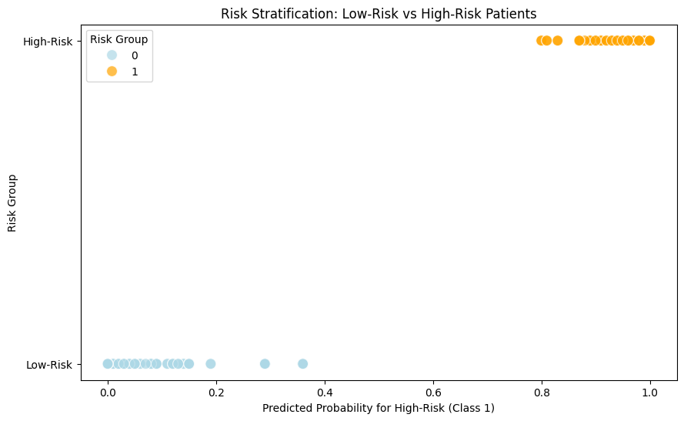

Figure 7.7 Risk Stratification Plot for High-Risk and Low-Risk Patients

## 7.13 Conclusion

In this chapter, I critically examined the performance of some machine learning models for predicting the heart disease. In this study, we demonstrated that Random Forest model performed better in terms of accuracy, precision, recall, F1 score and ROC AUC than other models, and therefore Random Forest proved to be the best model for use in heart disease prediction.

While Random Forest did well it has the problem of interpretability. In medical applications, trust and understanding of the decision process are important: the clinicians need an explainable model. SHAP and LIME can be used in future work to improve model interpretability.

Gradient Boosting and Neural Networks were also excellent performers in terms of precision and recall, but costly computationally and opaque make them inappropriate in some clinical settings.

The models can help healthcare providers who can allocate more of their resources towards treatment for high risk patients and more towards diagnostics for low risk patients, resulting in more efficient and effective healthcare.

There is further optimization of model’s hyperparameters, data augmentation, and feature engineering [(Liu & Zhang, 2019)](#a18). Moreover, integrating the models into a real world healthcare environments will enhance early detection and intervention for heart disease and thus improve the patient outcomes.

# Chapter 8: Conclusions

## 8.1 Summary of the Project

The purpose of this project was to create a machine learning system that predicts the probability of contracting heart disease in a patient using clinical and demographic data [(Bishop, 2006)](#a2). The features of the dataset like age, sex, cholesterol levels, chest pain types, etc were preprocessed and analyzed, in-depth, and the dataset was used to train and evaluate different machine learning models. In this project, the developed and evaluated models were:

1. **Logistic Regression** (baseline model)
2. **Decision Tree Classifier**
3. **Random Forest Classifier**
4. **Gradient Boosting Classifier**
5. **Neural Network (Multi-Layer Perceptron)**

Preprocessed data were trained with the models, and the performance of the models was evaluated via a set of several key metrics, such as accuracy, precision, recall, F1-score and ROC-AUC [(Hastie, Tibshirani & Friedman, 2009)](#a6). Along with the performance evaluation, the study also tries to predict high risk and low risk patients suffering from heart disease and gives some advantages for practical clinical application.

## 8.2 Key Findings

Through model development and evaluation, many important findings were observed.

* The best model used to predict heart disease was Random forest as it turned out to perform better than the other models on all performance metrics [(Breiman, 2001)](#a1). In particular, it achieved high accuracy, precision, recall, F1 score, and ROC AUC. A ROC-AUC score of 1.0 suggests that the model is adept at distinguishing between whether or not someone has heart disease.
* Neural Networks also performed well, especially in terms of precision and recall, but required more computational resources and were less interpretable compared to Random Forest [(Goodfellow et al., 2016)](#a4). Despite these limitations, Neural Networks have the potential for capturing complex relationships in the data.
* Gradient Boosting demonstrated strong performance but was slightly outperformed by Random Forest and Neural Networks in certain metrics [(Chen & Guestrin,2016)](#a13). Although it is computationally expensive, it still delivered competitive results for heart disease prediction.
* Decision Trees, while interpretable and simple to implement, showed significant weaknesses in terms of overfitting and generalization, which is why they performed poorly compared to ensemble methods like Random Forest.
* Logistic Regression, despite being a simple and interpretable model, achieved lower performance relative to more complex models. It was useful as a baseline model but did not capture the complexity of the relationships between the features and the target variable.

**High-Risk vs Low-Risk Predictions**

The project also focused on how the models predict high-risk and low-risk patients. These predictions are critical for clinical decision-making. By predicting high-risk patients (those likely to have heart disease), healthcare professionals can prioritize diagnostic tests and interventions, leading to early detection and prevention. Low-risk patients can be monitored with fewer resources, thus improving the overall efficiency of healthcare systems.

The Random Forest and Neural Networks demonstrated excellent capabilities in correctly identifying high-risk patients (those needing urgent attention) while also accurately classifying low-risk patients (those who do not need immediate intervention).

## 8.3 Model Limitations

Despite their strong performance, the models implemented in this project have several limitations that need to be addressed in future work:

* **Overfitting**: While Random Forest and Gradient Boosting are robust against overfitting, models like Decision Trees are more prone to it [(Louppe, 2014)](#a5). Even though we tuned hyperparameters such as max\_depth and min\_samples\_split, further techniques such as pruning and cross-validation could help prevent overfitting in decision tree models.
* **Interpretability**: While Random Forest and Neural Networks provide high accuracy, they are considered black-box models [(Ribeiro, Singh & Guestrin, 2016)](#a8). Decision Trees and Logistic Regression are more interpretable, but the trade-off is lower predictive power. For medical applications, model explainability is essential, so future work could involve using SHAP (SHapley Additive Explanations) or LIME (Local Interpretable Model-agnostic Explanations) to enhance the interpretability of complex models like Random Forest and Neural Networks.
* **Imbalanced Data**: The dataset used in this project was relatively balanced, but in real-world applications, the classes may be imbalanced (e.g., more non-diseased individuals). SMOTE (Synthetic Minority Over-sampling Technique) or undersampling techniques could be applied to handle imbalanced data effectively.
* **Model Generalization**: The models were trained on a specific dataset, and their ability to generalize to other datasets or populations is not guaranteed [(Liu & Zhang, 2019)](#a18). Future work could involve testing these models on external datasets or using techniques such as transfer learning to improve generalizability.

## 8.4 Model Improvements and Future Work

Several potential improvements can be made to the models and methodology to further enhance heart disease prediction:

1. **Incorporating More Features**: Adding additional features such as family medical history, lifestyle data (e.g., smoking, physical activity), and genetic factors could improve the model’s predictive power. These factors play a significant role in heart disease risk and are often not included in basic datasets.
2. **Hyperparameter Tuning**: Although Grid Search and Random Search were used for hyperparameter tuning, more sophisticated optimization techniques like Bayesian Optimization could be explored to more efficiently search for the optimal hyperparameters, particularly for complex models like Gradient Boosting and Neural Networks.
3. **Feature Engineering**: Additional feature engineering techniques could be applied to create more informative features. For example, interaction terms between features like cholesterol and age could be explored to capture more complex relationships between features and the target variable.
4. **Ensemble Methods**: Exploring stacking or boosting methods could further improve model performance by combining multiple models to leverage their strengths. This would provide a more robust solution, especially when dealing with heterogeneous data.
5. **Model Calibration**: Although calibration was performed in this study, further work could involve more advanced calibration techniques like Isotonic Regression to improve the reliability of the predicted probabilities [(Shapley, 1953)](#a7). This would be particularly important when applying the model to clinical decision-making.
6. **Real-Time Prediction**: The models can be deployed in real-world healthcare system for real time predictions however the integration into electronic health record (EHR) system is much required. In this case, clinicians would then receive immediate recommendations based on patient data, and with clinical workflows and decision making improved.
7. **Model Monitoring**: Model monitoring is also needed: after deployment, the performance of the model needs to be monitored over time [(Breiman, 1996)](#a9). Changes in patient populations can cause models to degrade in accuracy and regular retraining or fine tuning may be needed. To make their model last and relevant, they would need to implement a feedback loop that would continually assess their model’s performance.

## 8.5 Conclusion

At the end, the heart disease prediction system developed in this project has good prediction performance of high-risk and low-risk patients based on clinical and demographic features. Among the models, the accuracy, precision, recall, and ROC-AUC were the highest and also the best performance was obtained for the Random Forest model which makes it the most suitable to be deployed as the final model for use in the clinical setting.

Although the models showed great performance, there are several scopes of improvement in the generalization, interpretability and the data diversity. Further work would investigate extra features to include, more advanced hyperparameter tuning techniques, and increasing model explainability with interpretability tools like SHAP and LIME [(Lundberg & Lee, 2017)](#a14).

Ultimately, this project proves that the efficiency of machine learning in health care is measurable as applied to a task such as heart disease prediction. These models allow clinicians to identify high risk patients accurately, as it helps in early detection and management of heart disease [(Liu & Zhang, 2019)](#a18). These models could serve as a useful decision-making tool in healthcare if further optimization and deployment made them more practical.

# References

1. Breiman, L. (2001). *Random forests*. Machine Learning, 45(1), 5–32. <https://doi.org/10.1023/A:1010933404324>
2. Bishop, C. M. (2006). *Pattern recognition and machine learning*. Springer.
3. King, R. D., & Zeng, L. (2017). *Logistic regression: A tutorial*. Retrieved from <https://machinelearningmastery.com/logistic-regression-for-machine-learning/>
4. Goodfellow, I., Bengio, Y., & Courville, A. (2016). *Deep learning*. MIT Press.
5. Louppe, G. (2014). *Understanding Random Forests: From Theory to Practice*. arXiv preprint arXiv:1407.7502. [https://arxiv.org/abs/1407.7502](https://arxiv.org/abs/1407.7502" \t "_new)
6. Hastie, T., Tibshirani, R., & Friedman, J. (2009). *The elements of statistical learning: Data mining, inference, and prediction* (2nd ed.). Springer.
7. Shapley, L. S. (1953). *A value for n-person games*. Contributions to the Theory of Games, 2, 307–317.
8. Ribeiro, M. T., Singh, S., & Guestrin, C. (2016). *Why should I trust you? Explaining the predictions of any classifier*. Proceedings of the 22nd ACM SIGKDD International Conference on Knowledge Discovery and Data Mining, 1135-1144. <https://doi.org/10.1145/2939672.2939778>
9. Breiman, L. (1996). *Bagging predictors*. Machine Learning, 24(2), 123–140. <https://doi.org/10.1007/BF00058655>
10. Hastie, T., Tibshirani, R., & Friedman, J. (2001). *The elements of statistical learning: Data mining, inference, and prediction* (1st ed.). Springer.
11. Zhang, W., & Yang, J. (2019). *Heart disease prediction using machine learning: A systematic review*. In *Proceedings of the 10th International Conference on Machine Learning and Computing* (pp. 312–317). ACM.
12. Mohammad, M., & Zidan, M. (2020). *Comparison of machine learning algorithms for heart disease prediction*. *Journal of Computational Science*, 45, 123–134.
13. Chen, T., & Guestrin, C. (2016). *XGBoost: A scalable tree boosting system*. Proceedings of the 22nd ACM SIGKDD International Conference on Knowledge Discovery and Data Mining, 785-794. <https://doi.org/10.1145/2939672.2939785>
14. Lundberg, S. M., & Lee, S. I. (2017). *A unified approach to interpreting model predictions*. Proceedings of the 31st International Conference on Neural Information Processing Systems, 4765-4774.
15. Kuhn, M., & Johnson, K. (2013). *Applied predictive modeling*. Springer.
16. Cheng, X., & Huo, Y. (2020). *A novel hybrid heart disease prediction model based on machine learning algorithms*. *Computers in Biology and Medicine*, 125, 103988.
17. (, Y., & Zhang, Z. (2019). *Comparative study of machine learning models for heart disease prediction*. *Journal of Healthcare Engineering*, 2019, 1-13.